Приложение

Описание местоположения границ публичного сервитута

Основной лист

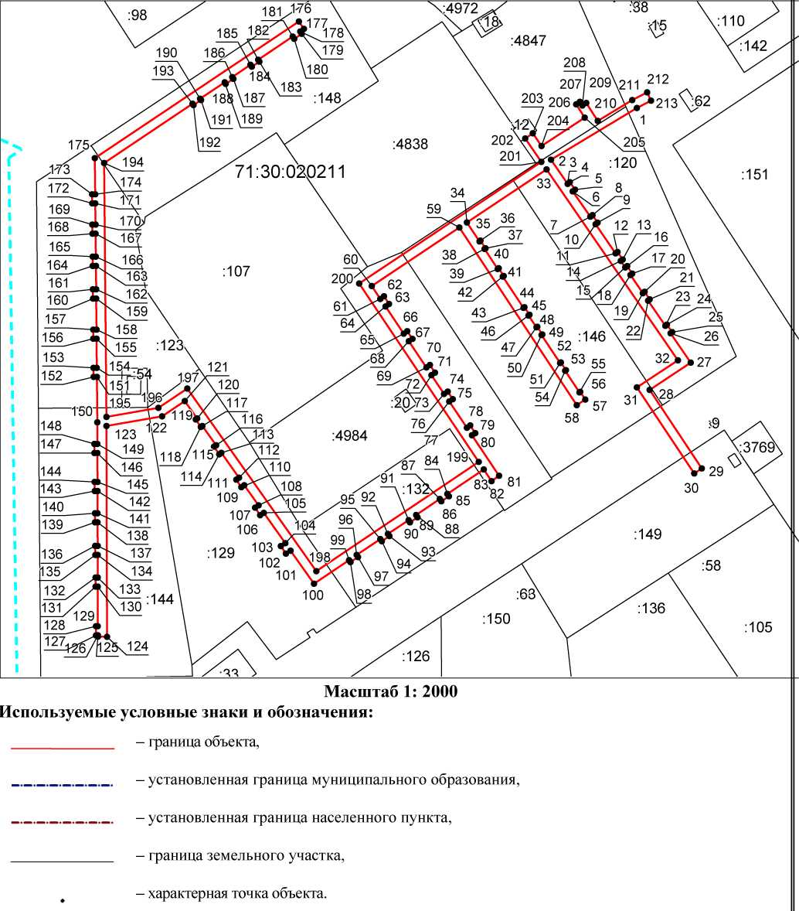

Ведомость координат поворотных точек

@142056
Обозначение характерных точек границ | Координаты
Обозначение характерных точек границ | X | Y
1 | 744672.68 | 257254.79
2 | 744649.98 | 257217.34
3 | 744639.46 | 257224.56
4 | 744640.20 | 257225.55
5 | 744636.87 | 257227.80
6 | 744636.15 | 257226.82
7 | 744624.99 | 257234.48
8 | 744625.67 | 257235.41
9 | 744622.37 | 257237.66
10 | 744621.69 | 257236.74
11 | 744608.91 | 257245.50
12 | 744609.55 | 257246.36
13 | 744606.23 | 257248.62
14 | 744605.61 | 257247.77
15 | 744602.77 | 257249.72
16 | 744603.38 | 257250.54
17 | 744600.07 | 257252.78
18 | 744599.47 | 257251.98
19 | 744591.52 | 257257.43
20 | 744592.09 | 257258.20
21 | 744588.78 | 257260.44
22 | 744588.22 | 257259.70
23 | 744577.18 | 257267.27
24 | 744577.70 | 257267.96
25 | 744574.39 | 257270.20
26 | 744573.89 | 257269.53
27 | 744561.00 | 257278.37
28 | 744549.06 | 257260.38
29 | 744514.64 | 257283.20
30 | 744512.40 | 257279.88
31 | 744550.16 | 257254.82
32 | 744562.08 | 257272.78
33 | 744645.78 | 257215.36
34 | 744622.47 | 257180.58
35 | 744614.20 | 257186.04
36 | 744614.51 | 257186.50
37 | 744611.17 | 257188.70
38 | 744610.87 | 257188.24
39 | 744602.12 | 257194.01
40 | 744602.42 | 257194.46
41 | 744599.07 | 257196.66
42 | 744598.79 | 257196.22
43 | 744585.04 | 257205.28
44 | 744585.32 | 257205.69
45 | 744581.99 | 257207.90
46 | 744581.71 | 257207.49
47 | 744576.50 | 257210.92
48 | 744576.76 | 257211.33
49 | 744573.42 | 257213.53
50 | 744573.16 | 257213.13
51 | 744560.83 | 257221.27
52 | 744561.08 | 257221.66
53 | 744557.74 | 257223.85
54 | 744557.49 | 257223.48
55 | 744548.01 | 257229.73
56 | 744548.25 | 257230.10
57 | 744544.90 | 257232.30
58 | 744542.39 | 257228.56
59 | 744620.25 | 257177.26
60 | 744594.63 | 257139.01
61 | 744589.00 | 257142.77
62 | 744590.14 | 257144.34
63 | 744586.80 | 257146.55
64 | 744585.67 | 257144.99
65 | 744573.71 | 257152.98
66 | 744574.82 | 257154.52
67 | 744571.48 | 257156.76
68 | 744570.39 | 257155.21
69 | 744558.88 | 257162.90
70 | 744559.99 | 257164.40
71 | 744556.65 | 257166.62
72 | 744555.55 | 257165.12
73 | 744547.32 | 257170.62
74 | 744548.34 | 257172.16
75 | 744545.01 | 257174.37
76 | 744544.00 | 257172.84
77 | 744532.49 | 257180.53
78 | 744533.49 | 257182.04
79 | 744530.16 | 257184.25
80 | 744529.16 | 257182.75
81 | 744511.41 | 257194.61
82 | 744509.09 | 257191.36
83 | 744514.23 | 257187.93
84 | 744503.47 | 257172.03
85 | 744502.46 | 257172.71
86 | 744500.23 | 257169.40
87 | 744501.23 | 257168.72
88 | 744494.22 | 257158.37
89 | 744493.25 | 257159.02
90 | 744491.01 | 257155.71
91 | 744491.98 | 257155.06
92 | 744485.90 | 257146.06
93 | 744484.97 | 257146.70
94 | 744482.73 | 257143.38
95 | 744483.66 | 257142.75
96 | 744476.67 | 257132.43
97 | 744475.77 | 257133.03
98 | 744473.54 | 257129.72
99 | 744474.42 | 257129.12
100 | 744464.06 | 257113.80
101 | 744478.61 | 257103.55
102 | 744477.27 | 257101.51
103 | 744480.62 | 257099.30
104 | 744481.89 | 257101.25
105 | 744495.18 | 257091.88
106 | 744494.12 | 257090.25
107 | 744497.44 | 257088.02
108 | 744498.45 | 257089.58
109 | 744507.31 | 257083.33
110 | 744506.41 | 257082.02
111 | 744509.75 | 257079.79
112 | 744510.59 | 257081.02
113 | 744521.51 | 257073.32
114 | 744520.85 | 257072.36
115 | 744524.19 | 257070.13
116 | 744524.78 | 257071.02
117 | 744533.30 | 257065.02
118 | 744532.85 | 257064.34
119 | 744536.16 | 257062.10
120 | 744536.58 | 257062.71
121 | 744544.18 | 257057.35
122 | 744537.47 | 257047.42
123 | 744533.22 | 257023.13
124 | 744440.84 | 257023.40
125 | 744440.87 | 257019.36
126 | 744441.46 | 257019.36
127 | 744441.45 | 257018.58
128 | 744445.45 | 257018.55
129 | 744445.46 | 257019.34
130 | 744462.81 | 257019.30
131 | 744462.80 | 257018.39
132 | 744466.81 | 257018.36
133 | 744466.81 | 257019.29
134 | 744476.72 | 257019.27
135 | 744476.71 | 257018.26
136 | 744480.71 | 257018.23
137 | 744480.72 | 257019.26
138 | 744490.99 | 257019.23
139 | 744490.99 | 257018.14
140 | 744494.98 | 257018.11
141 | 744494.99 | 257019.22
142 | 744504.72 | 257019.20
143 | 744504.71 | 257018.02
144 | 744508.72 | 257017.98
145 | 744508.73 | 257019.19
146 | 744521.41 | 257019.16
147 | 744521.40 | 257017.87
148 | 744525.40 | 257017.84
149 | 744525.42 | 257019.15
150 | 744534.89 | 257019.13
151 | 744554.78 | 257018.94
152 | 744554.76 | 257017.50
153 | 744558.77 | 257017.46
154 | 744558.78 | 257018.91
155 | 744571.53 | 257018.79
156 | 744571.52 | 257017.38
157 | 744575.52 | 257017.34
158 | 744575.53 | 257018.75
159 | 744589.17 | 257018.63
160 | 744589.15 | 257017.23
161 | 744593.16 | 257017.20
162 | 744593.17 | 257018.59
163 | 744603.48 | 257018.50
164 | 744603.47 | 257017.13
165 | 744607.47 | 257017.10
166 | 744607.49 | 257018.46
167 | 744617.59 | 257018.37
168 | 744617.58 | 257016.99
169 | 744621.58 | 257016.96
170 | 744621.59 | 257018.33
171 | 744630.87 | 257018.24
172 | 744630.85 | 257016.90
173 | 744634.86 | 257016.86
174 | 744634.87 | 257018.21
175 | 744650.67 | 257018.06
176 | 744710.65 | 257107.16
177 | 744707.38 | 257109.40
178 | 744706.22 | 257107.75
179 | 744705.19 | 257108.43
180 | 744702.99 | 257105.10
181 | 744704.00 | 257104.43
182 | 744693.85 | 257089.36
183 | 744692.98 | 257089.94
184 | 744690.78 | 257086.60
185 | 744691.62 | 257086.04
186 | 744686.22 | 257078.03
187 | 744685.46 | 257078.54
188 | 744683.25 | 257075.20
189 | 744683.99 | 257074.71
190 | 744676.78 | 257064.00
191 | 744676.14 | 257064.42
192 | 744673.94 | 257061.09
193 | 744674.55 | 257060.69
194 | 744648.55 | 257022.08
195 | 744537.28 | 257023.11
196 | 744541.22 | 257045.82
197 | 744549.69 | 257058.37
198 | 744469.61 | 257114.77
199 | 744517.55 | 257185.71
200 | 744595.74 | 257133.46
201 | 744649.03 | 257213.12
202 | 744659.31 | 257206.06
203 | 744661.58 | 257209.36
204 | 744656.01 | 257213.18
205 | 744668.43 | 257232.07
206 | 744674.32 | 257228.32
207 | 744675.44 | 257229.94
208 | 744673.78 | 257231.05
209 | 744674.90 | 257232.72
210 | 744667.02 | 257237.75
211 | 744676.13 | 257252.78
212 | 744679.55 | 257259.34
213 | 744675.90 | 257260.96
1 | 744672.68 | 257254.79

