Приложение

Описание местоположения границ публичного сервитута

Основной лист

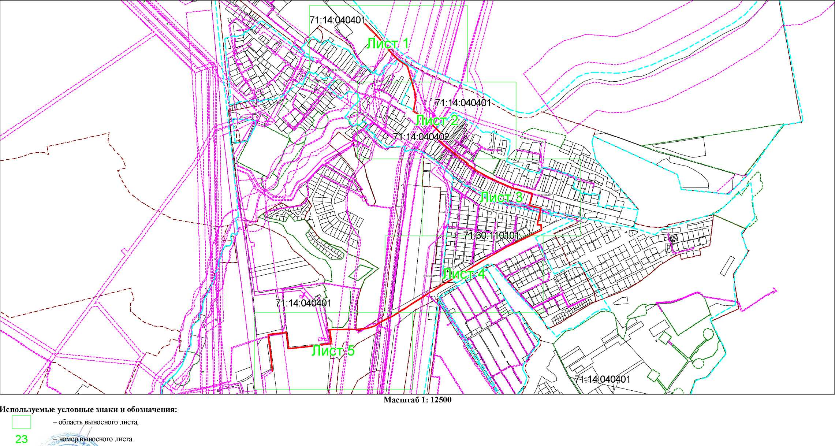

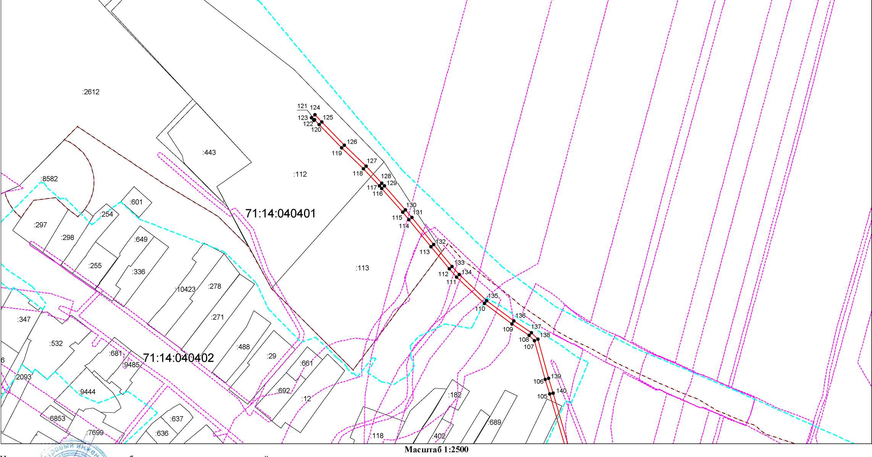

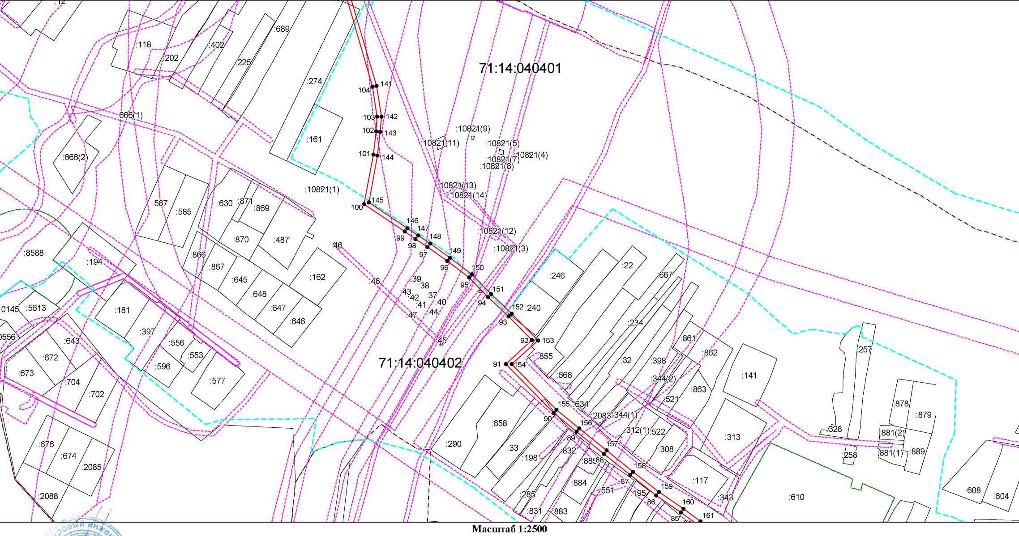

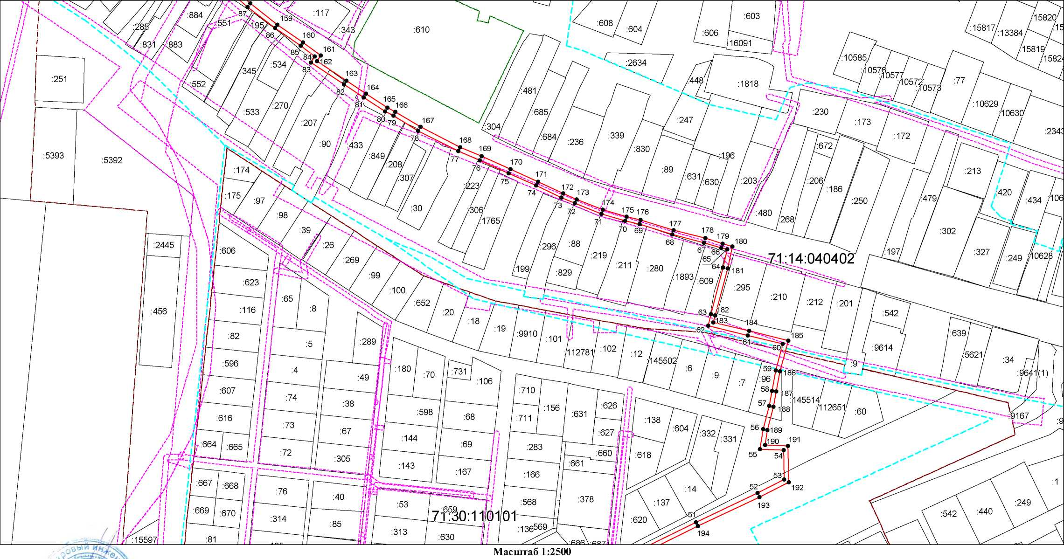

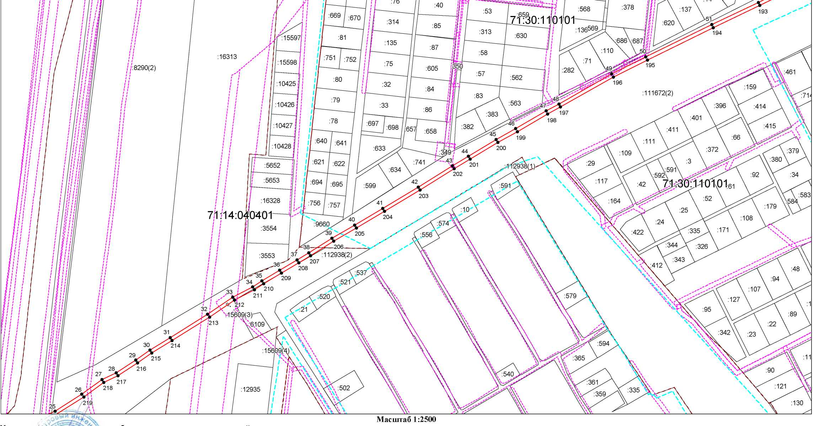

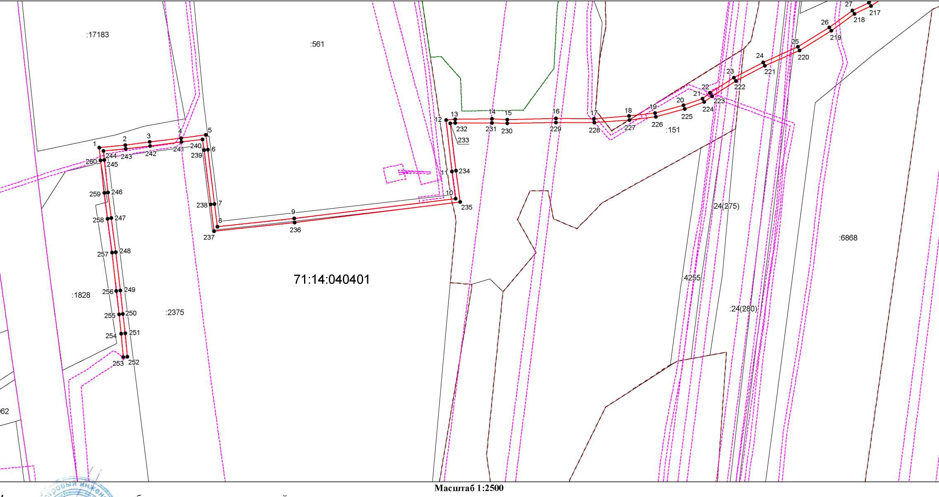

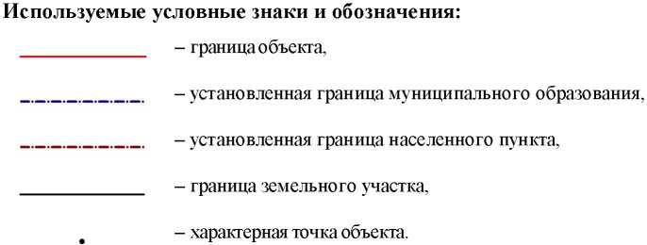
Ведомость координат поворотных точек

@142075
Обозначение характерных точек границ | Координаты
Обозначение характерных точек границ | X | Y
1 | 744508.11 | 254227.16
2 | 744510.69 | 254253.64
3 | 744513.75 | 254278.60
4 | 744517.86 | 254310.84
5 | 744521.01 | 254336.41
6 | 744505.86 | 254338.41
7 | 744450.07 | 254345.37
8 | 744426.65 | 254348.25
9 | 744435.13 | 254426.88
10 | 744455.49 | 254592.61
11 | 744483.68 | 254588.79
12 | 744536.46 | 254582.51
13 | 744537.34 | 254591.81
14 | 744537.60 | 254629.62
15 | 744536.87 | 254645.21
16 | 744538.02 | 254695.19
17 | 744537.84 | 254734.38
18 | 744540.48 | 254770.11
19 | 744543.58 | 254797.01
20 | 744551.45 | 254825.99
21 | 744558.56 | 254845.49
22 | 744564.25 | 254853.09
23 | 744580.07 | 254877.76
24 | 744595.80 | 254907.56
25 | 744611.52 | 254943.30
26 | 744631.62 | 254975.36
27 | 744649.07 | 254999.19
28 | 744657.17 | 255016.26
29 | 744672.50 | 255039.46
30 | 744684.27 | 255056.39
31 | 744699.29 | 255080.48
32 | 744727.04 | 255125.20
33 | 744747.25 | 255154.94
34 | 744759.71 | 255178.93
35 | 744766.77 | 255189.96
36 | 744779.51 | 255210.95
37 | 744791.94 | 255231.82
38 | 744800.20 | 255245.74
39 | 744817.52 | 255273.14
40 | 744833.40 | 255300.24
41 | 744853.28 | 255333.80
42 | 744878.40 | 255376.14
43 | 744903.92 | 255416.81
44 | 744915.28 | 255435.56
45 | 744935.18 | 255468.72
46 | 744948.24 | 255491.97
47 | 744969.35 | 255528.21
48 | 744977.77 | 255543.47
49 | 745013.46 | 255606.39
50 | 745033.70 | 255647.07
51 | 745072.33 | 255725.38
52 | 745098.66 | 255781.14
53 | 745110.95 | 255805.48
54 | 745137.65 | 255804.80
55 | 745138.71 | 255783.16
56 | 745156.92 | 255786.18
57 | 745178.02 | 255791.78
58 | 745191.61 | 255794.33
59 | 745210.29 | 255797.73
60 | 745234.26 | 255804.20
61 | 745242.07 | 255772.50
62 | 745250.85 | 255736.28
63 | 745261.22 | 255738.80
64 | 745303.84 | 255750.01
65 | 745320.07 | 255753.73
66 | 745321.64 | 255748.31
67 | 745326.30 | 255732.55
68 | 745333.81 | 255703.90
69 | 745342.97 | 255673.94
70 | 745345.99 | 255661.02
71 | 745352.36 | 255639.50
72 | 745361.98 | 255615.25
73 | 745367.25 | 255603.04
74 | 745378.00 | 255580.04
75 | 745389.14 | 255555.06
76 | 745401.13 | 255528.87
77 | 745409.35 | 255509.52
78 | 745427.84 | 255473.23
79 | 745441.57 | 255450.49
80 | 745445.49 | 255443.06
81 | 745458.27 | 255423.47
82 | 745470.11 | 255405.71
83 | 745490.09 | 255375.69
84 | 745495.46 | 255379.26
85 | 745505.06 | 255366.28
86 | 745521.09 | 255343.02
87 | 745540.48 | 255318.29
88 | 745560.44 | 255293.52
89 | 745581.35 | 255267.38
90 | 745599.45 | 255245.88
91 | 745645.37 | 255200.51
92 | 745668.21 | 255225.22
93 | 745690.54 | 255203.25
94 | 745708.99 | 255183.83
95 | 745727.70 | 255165.99
96 | 745743.00 | 255145.43
97 | 745756.24 | 255126.72
98 | 745764.12 | 255115.29
99 | 745770.97 | 255105.13
100 | 745796.93 | 255066.71
101 | 745843.79 | 255075.23
102 | 745866.08 | 255077.96
103 | 745879.90 | 255078.98
104 | 745908.10 | 255074.40
105 | 745994.70 | 255049.32
106 | 746011.03 | 255044.31
107 | 746053.86 | 255032.57
108 | 746059.99 | 255026.57
109 | 746072.82 | 255007.42
110 | 746095.35 | 254976.95
111 | 746124.88 | 254946.13
112 | 746134.11 | 254938.10
113 | 746158.70 | 254917.59
114 | 746188.85 | 254893.28
115 | 746197.03 | 254886.39
116 | 746223.46 | 254863.16
117 | 746226.44 | 254860.37
118 | 746245.49 | 254842.93
119 | 746268.72 | 254818.84
120 | 746294.59 | 254793.58
121 | 746299.88 | 254788.70
122 | 746299.10 | 254787.90
123 | 746301.96 | 254785.10
124 | 746305.62 | 254788.84
125 | 746297.35 | 254796.48
126 | 746271.56 | 254821.66
127 | 746248.29 | 254845.79
128 | 746229.16 | 254863.31
129 | 746226.14 | 254866.12
130 | 746199.63 | 254889.43
131 | 746191.39 | 254896.36
132 | 746161.24 | 254920.69
133 | 746136.71 | 254941.14
134 | 746127.64 | 254949.03
135 | 746098.41 | 254979.53
136 | 746076.10 | 255009.72
137 | 746063.09 | 255029.14
138 | 746055.92 | 255036.15
139 | 746012.15 | 255048.15
140 | 745995.84 | 255053.16
141 | 745908.98 | 255078.31
142 | 745880.08 | 255083.00
143 | 745865.69 | 255081.94
144 | 745843.19 | 255079.19
145 | 745798.79 | 255071.11
146 | 745774.29 | 255107.37
147 | 745767.42 | 255117.55
148 | 745759.52 | 255129.01
149 | 745746.24 | 255147.78
150 | 745730.70 | 255168.65
151 | 745711.83 | 255186.65
152 | 745693.40 | 255206.05
153 | 745668.07 | 255230.96
154 | 745645.24 | 255206.27
155 | 745602.39 | 255248.60
156 | 745584.45 | 255269.92
157 | 745563.56 | 255296.02
158 | 745543.62 | 255320.77
159 | 745524.31 | 255345.40
160 | 745508.32 | 255368.60
161 | 745496.41 | 255384.70
162 | 745491.21 | 255381.23
163 | 745473.43 | 255407.93
164 | 745461.61 | 255425.67
165 | 745448.95 | 255445.09
166 | 745445.05 | 255452.46
167 | 745431.34 | 255475.17
168 | 745412.97 | 255511.22
169 | 745404.79 | 255530.49
170 | 745392.78 | 255556.70
171 | 745381.64 | 255581.70
172 | 745370.90 | 255604.68
173 | 745365.68 | 255616.78
174 | 745356.14 | 255640.80
175 | 745349.85 | 255662.04
176 | 745346.83 | 255674.98
177 | 745337.65 | 255705.00
178 | 745330.16 | 255733.63
179 | 745325.48 | 255749.43
180 | 745322.85 | 255758.47
181 | 745302.88 | 255753.89
182 | 745260.24 | 255742.68
183 | 745253.79 | 255741.11
184 | 745245.95 | 255773.45
185 | 745237.16 | 255809.12
186 | 745209.41 | 255801.63
187 | 745190.89 | 255798.27
188 | 745177.14 | 255795.68
189 | 745156.08 | 255790.10
190 | 745142.49 | 255787.84
191 | 745141.47 | 255808.70
192 | 745108.53 | 255809.54
193 | 745095.06 | 255782.90
194 | 745068.73 | 255727.12
195 | 745030.12 | 255648.85
196 | 745009.92 | 255608.27
197 | 744974.27 | 255545.43
198 | 744965.87 | 255530.19
199 | 744944.76 | 255493.95
200 | 744931.72 | 255470.72
201 | 744911.86 | 255437.62
202 | 744900.52 | 255418.91
203 | 744874.98 | 255378.22
204 | 744849.84 | 255335.84
205 | 744829.96 | 255302.27
206 | 744814.10 | 255275.22
207 | 744796.78 | 255247.83
208 | 744788.50 | 255233.86
209 | 744776.09 | 255213.01
210 | 744763.37 | 255192.08
211 | 744756.25 | 255180.93
212 | 744743.81 | 255157.00
213 | 744723.68 | 255127.38
214 | 744695.89 | 255082.60
215 | 744680.93 | 255058.59
216 | 744669.18 | 255041.70
217 | 744653.67 | 255018.23
218 | 744645.61 | 255001.25
219 | 744628.30 | 254977.60
220 | 744607.98 | 254945.18
221 | 744592.20 | 254909.30
222 | 744576.61 | 254879.78
223 | 744560.97 | 254855.37
224 | 744555.00 | 254847.41
225 | 744547.63 | 254827.21
226 | 744539.64 | 254797.77
227 | 744536.50 | 254770.49
228 | 744533.84 | 254734.52
229 | 744534.02 | 254695.23
230 | 744532.87 | 254645.17
231 | 744533.60 | 254629.54
232 | 744533.35 | 254592.11
233 | 744532.84 | 254586.97
234 | 744484.18 | 254592.75
235 | 744452.01 | 254597.11
236 | 744431.15 | 254427.34
237 | 744422.25 | 254344.77
238 | 744449.58 | 254341.41
239 | 744505.35 | 254334.45
240 | 744516.55 | 254332.97
241 | 744513.89 | 254311.34
242 | 744509.78 | 254279.10
243 | 744506.71 | 254254.08
244 | 744504.51 | 254231.52
245 | 744495.40 | 254232.40
246 | 744461.87 | 254236.01
247 | 744435.47 | 254239.48
248 | 744400.50 | 254244.15
249 | 744361.11 | 254248.63
250 | 744336.87 | 254251.28
251 | 744317.04 | 254253.66
252 | 744293.07 | 254255.85
253 | 744292.68 | 254251.87
254 | 744316.62 | 254249.68
255 | 744336.41 | 254247.30
256 | 744360.67 | 254244.65
257 | 744400.01 | 254240.18
258 | 744434.95 | 254235.52
259 | 744461.39 | 254232.03
260 | 744495.00 | 254228.42

