Приложение

Описание местоположения границ публичного сервитута

Основной лист

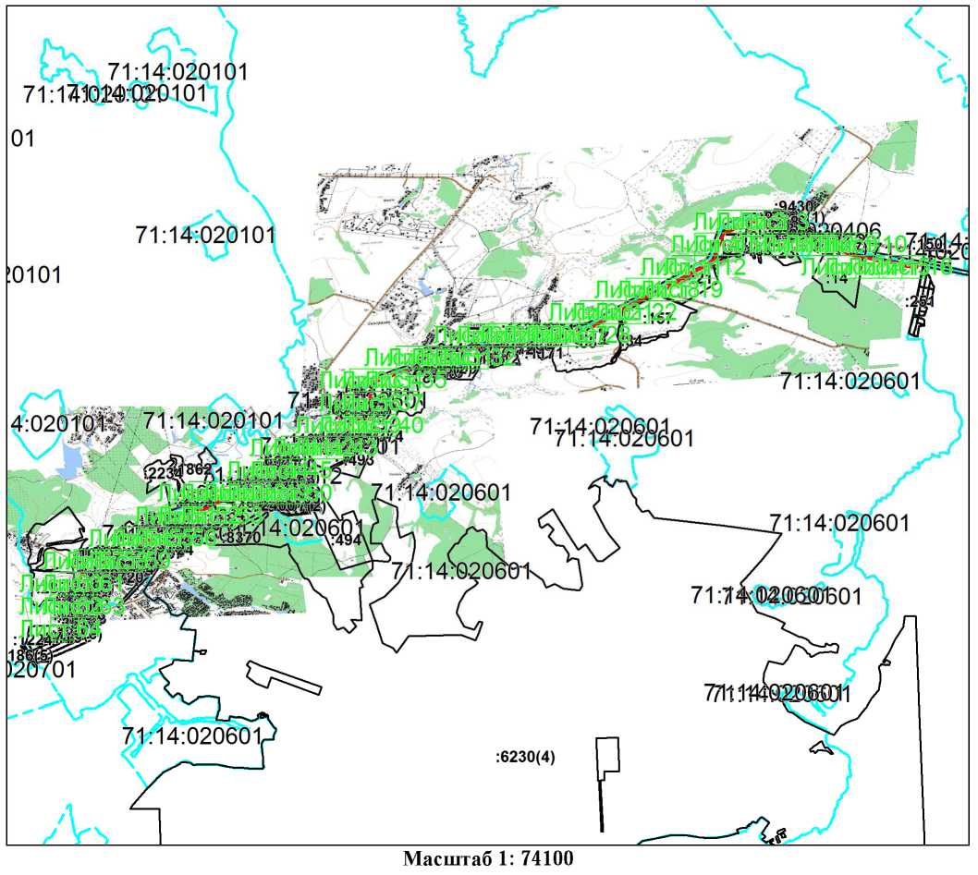
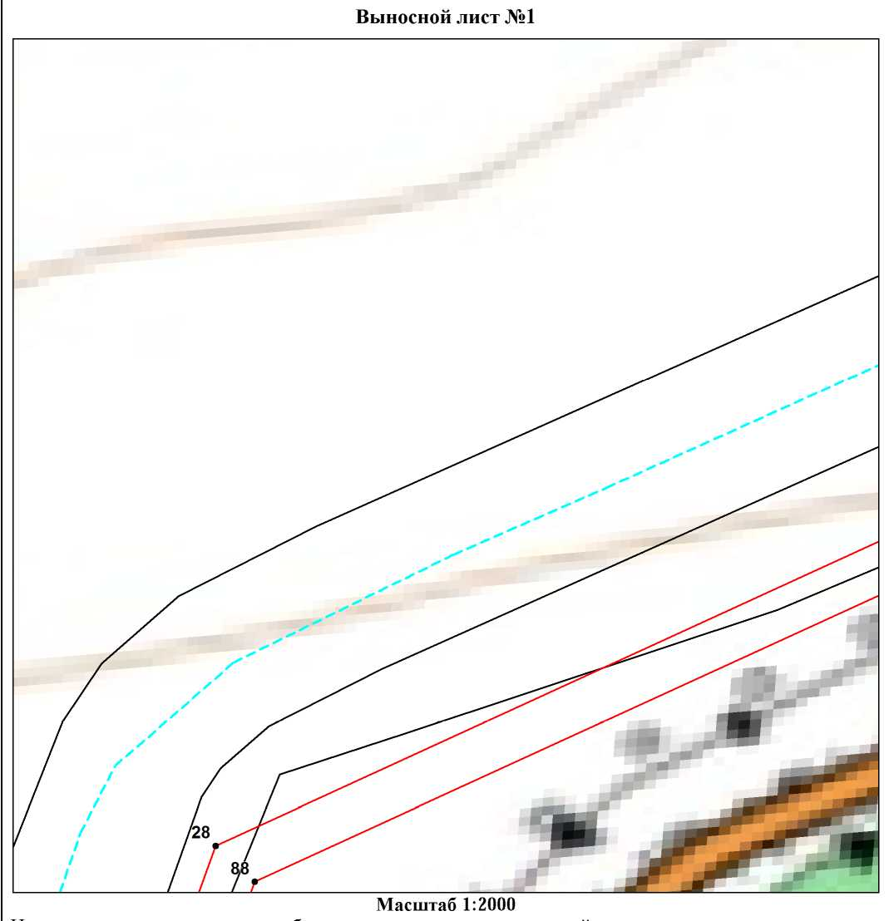
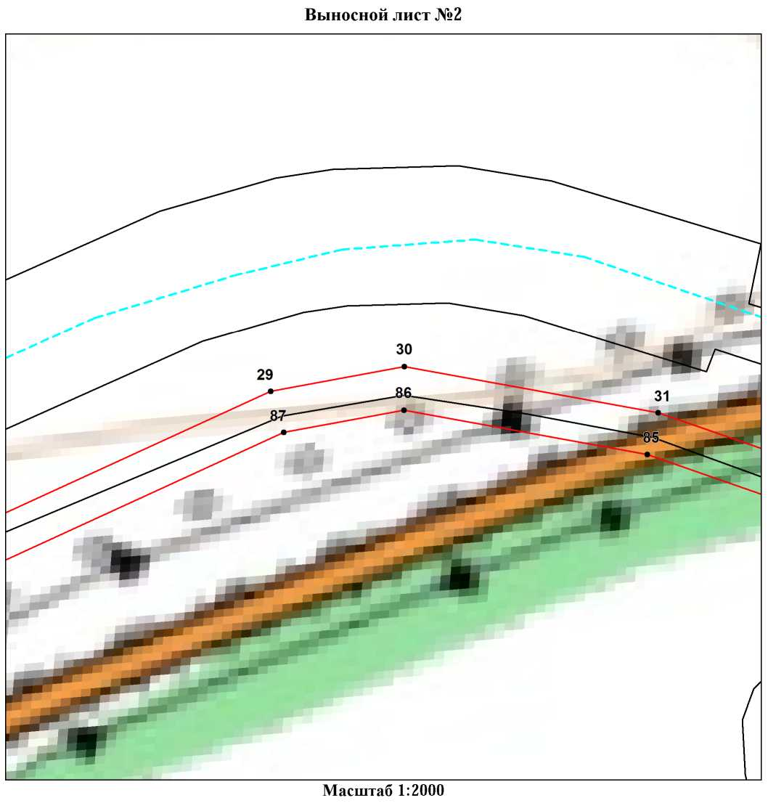
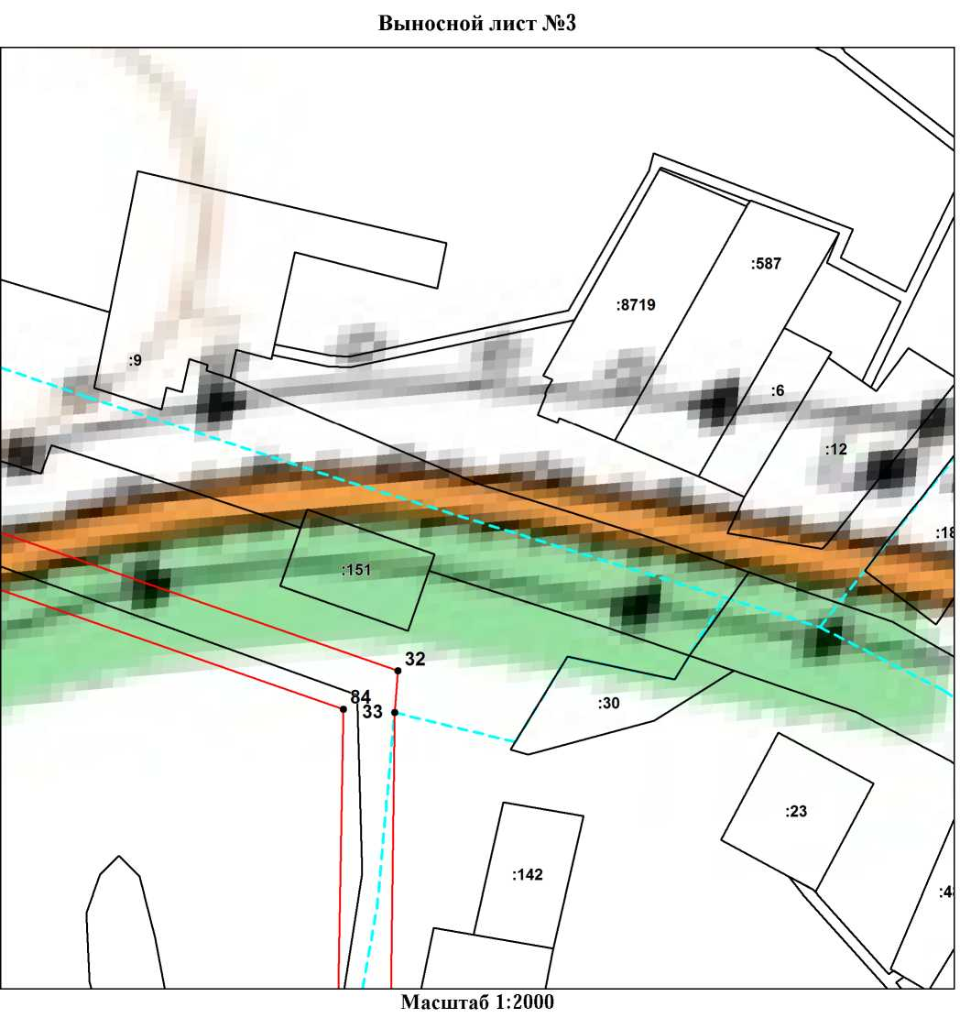
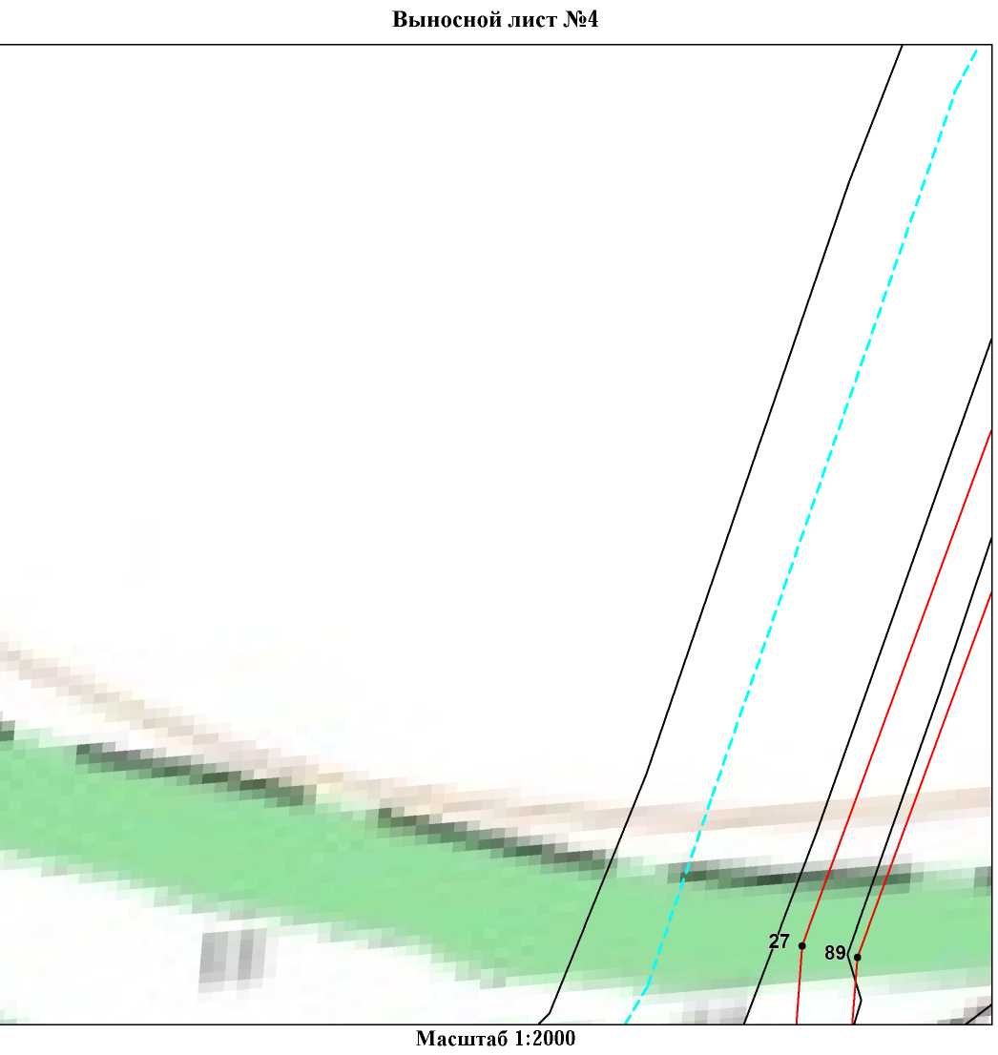
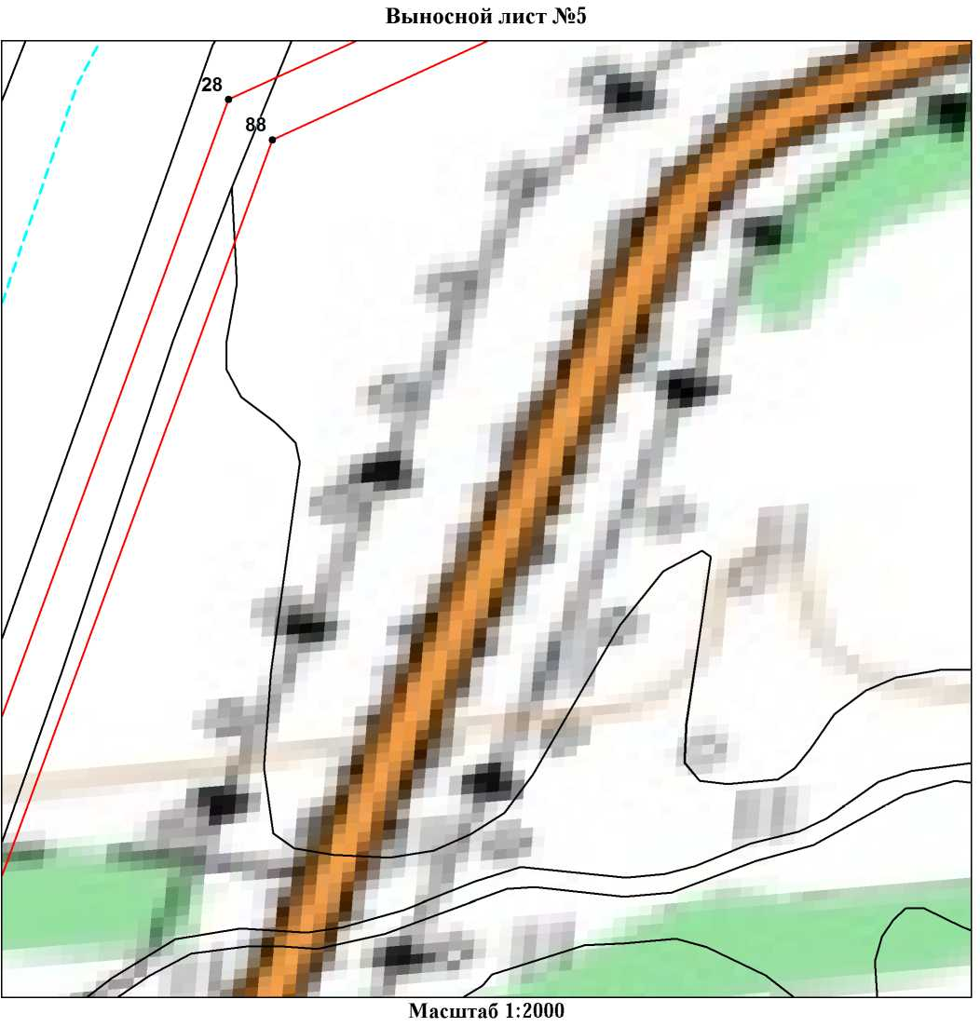
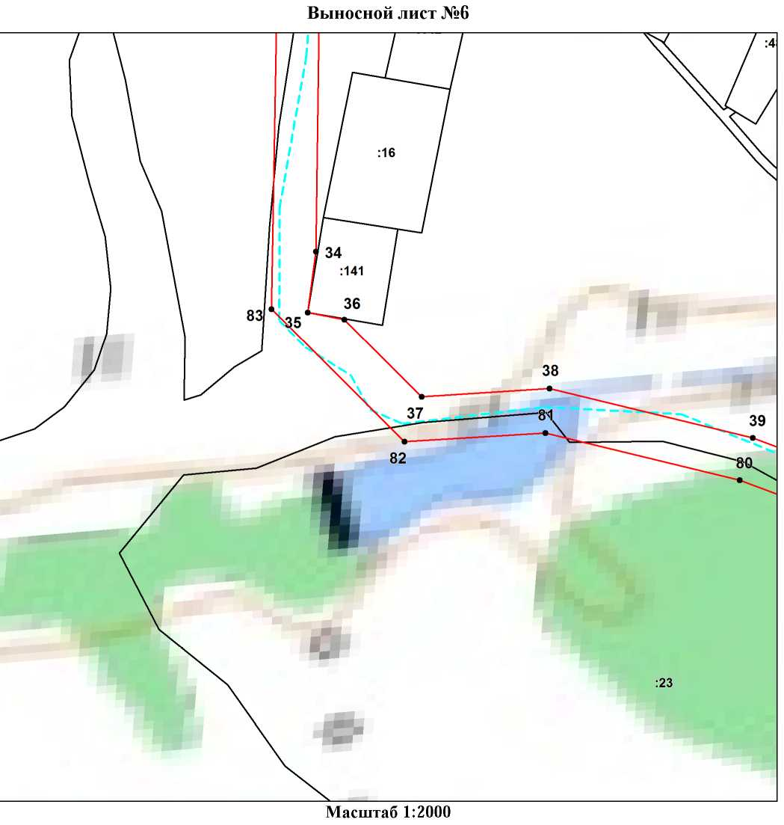
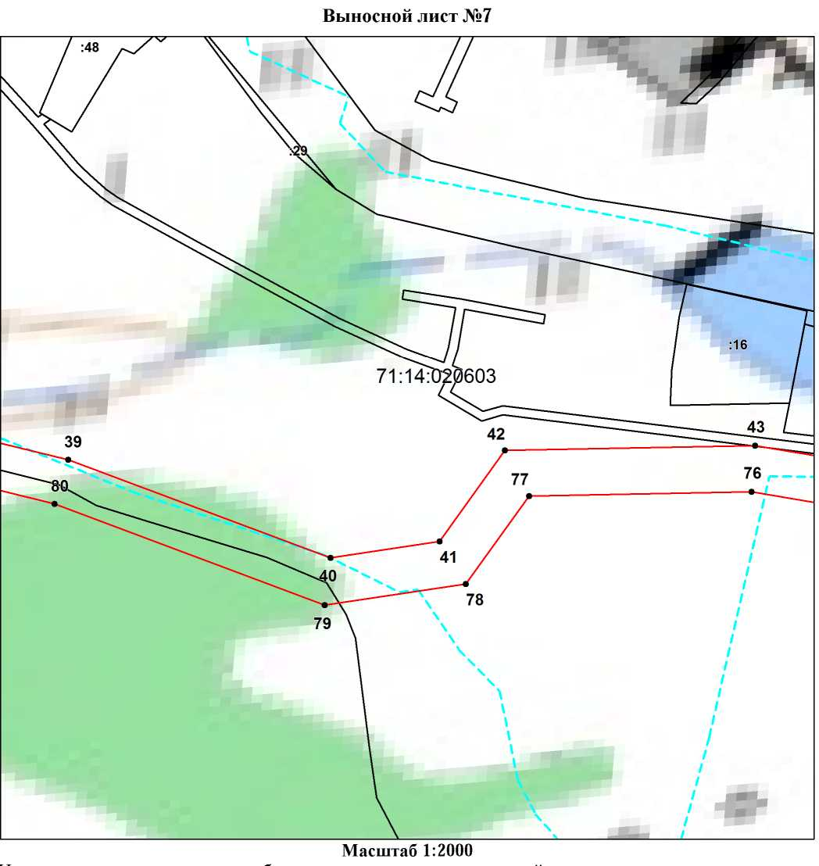
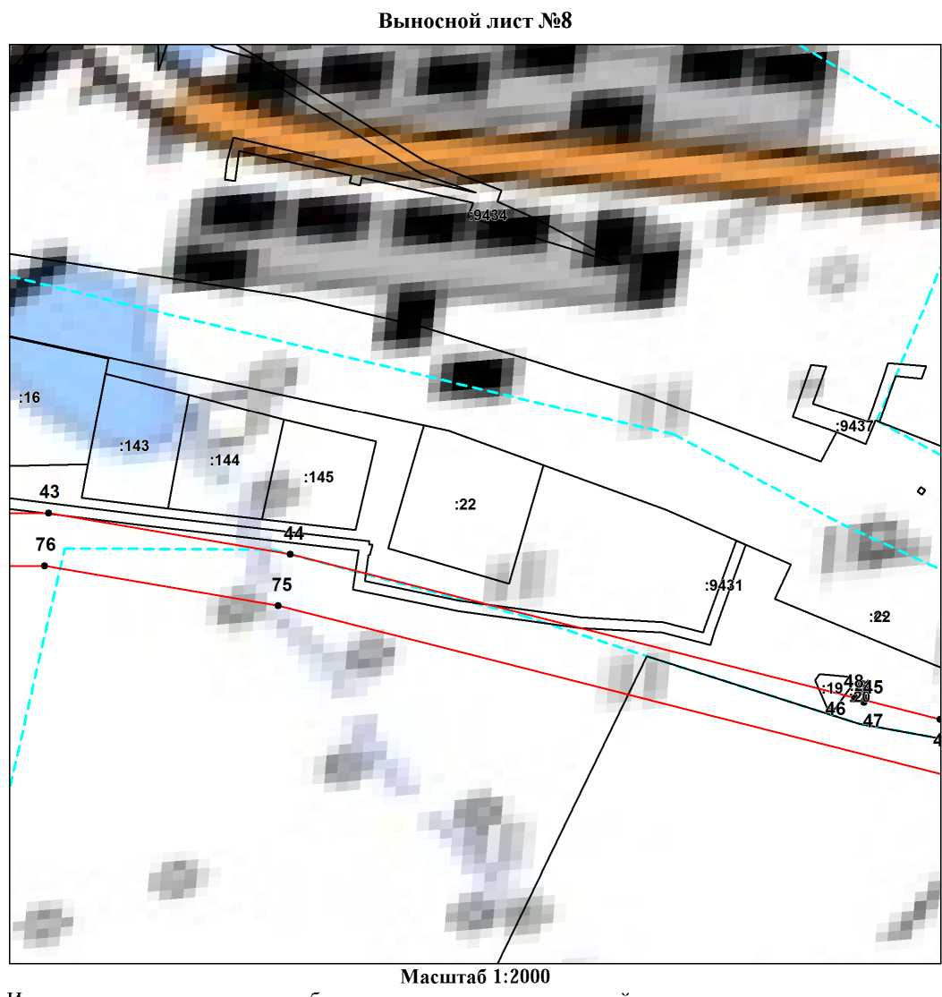
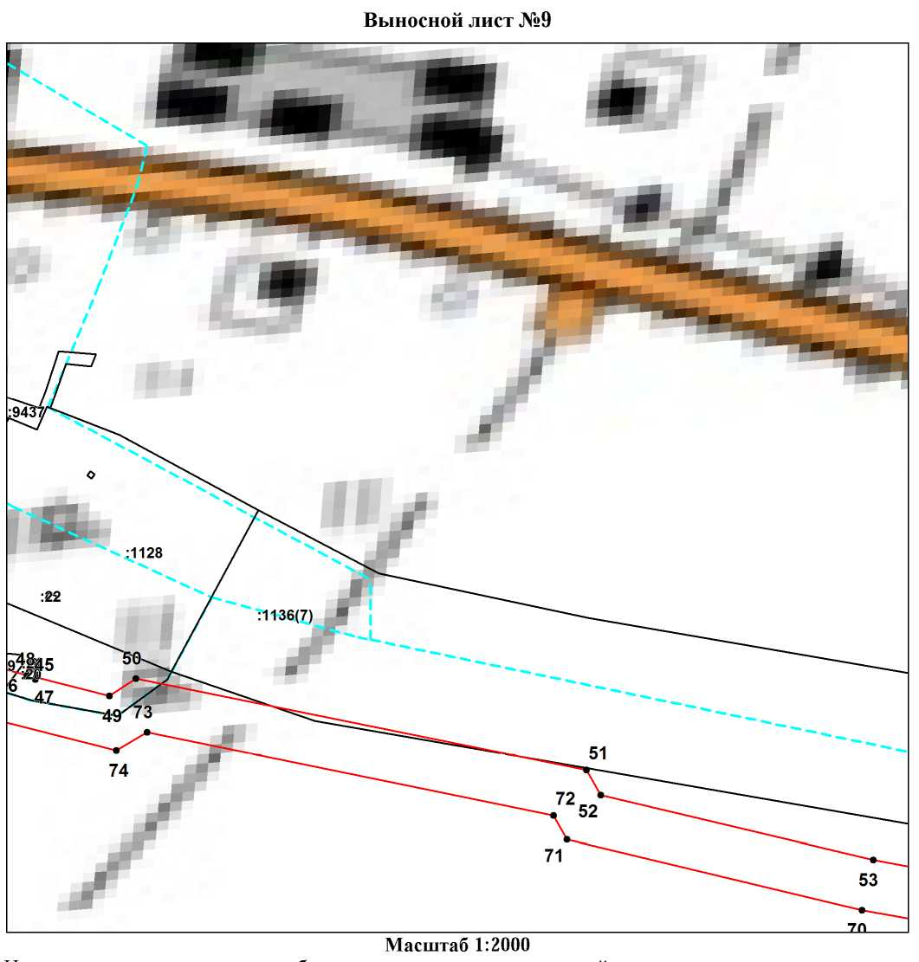
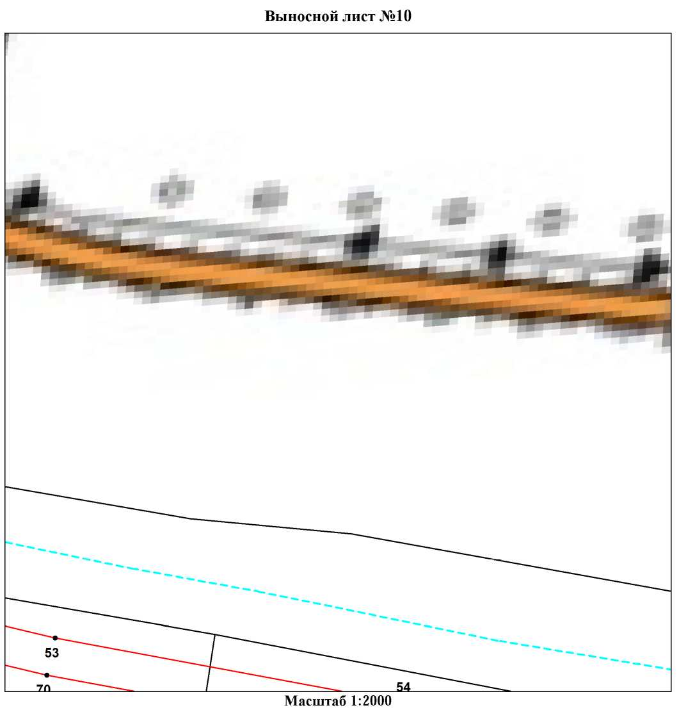
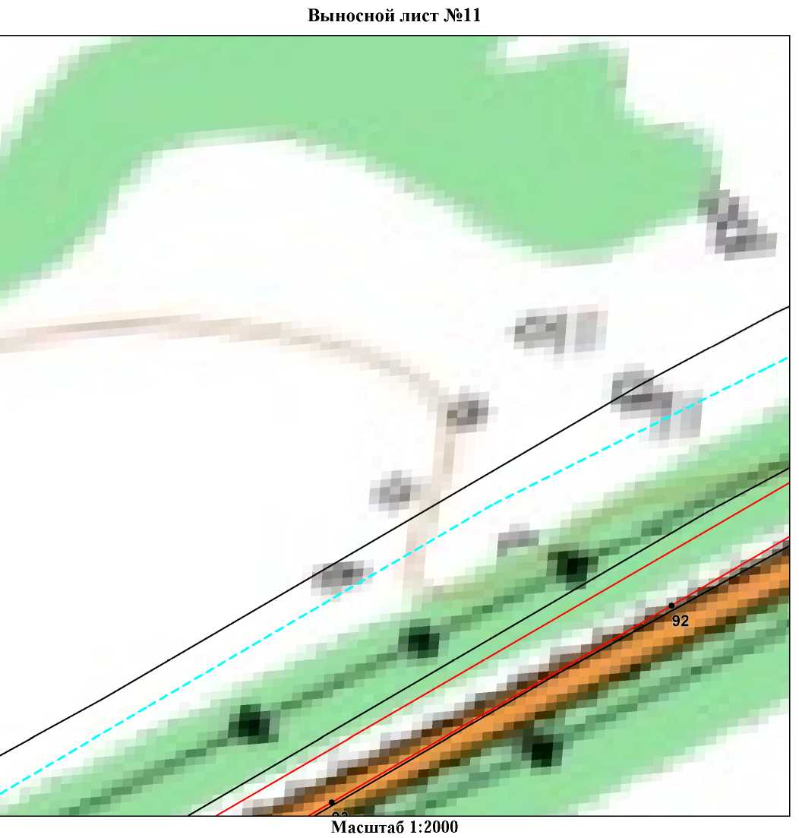
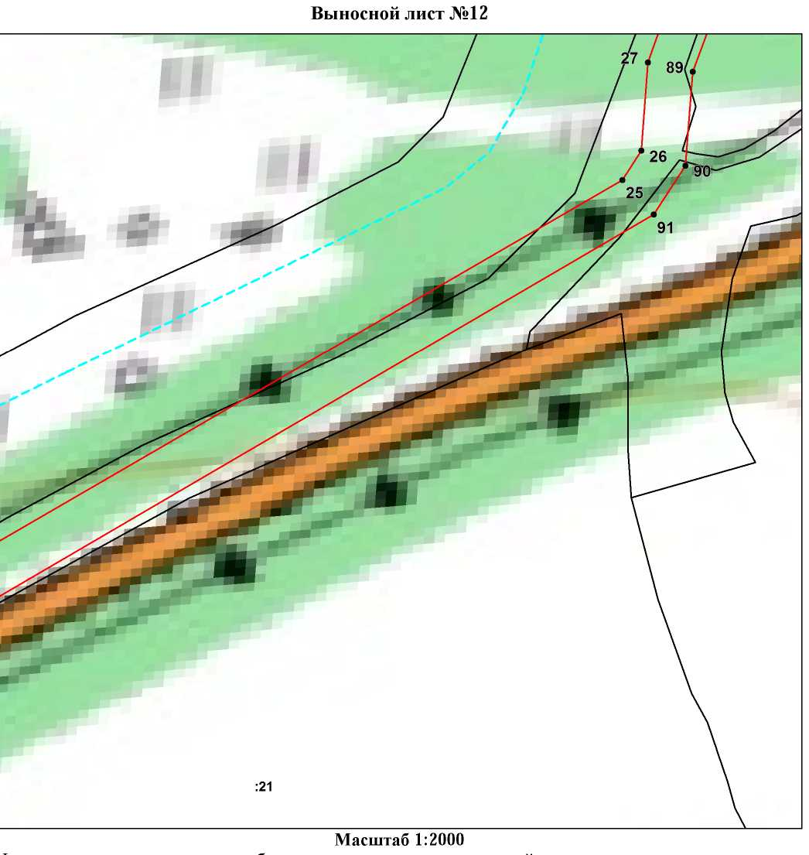
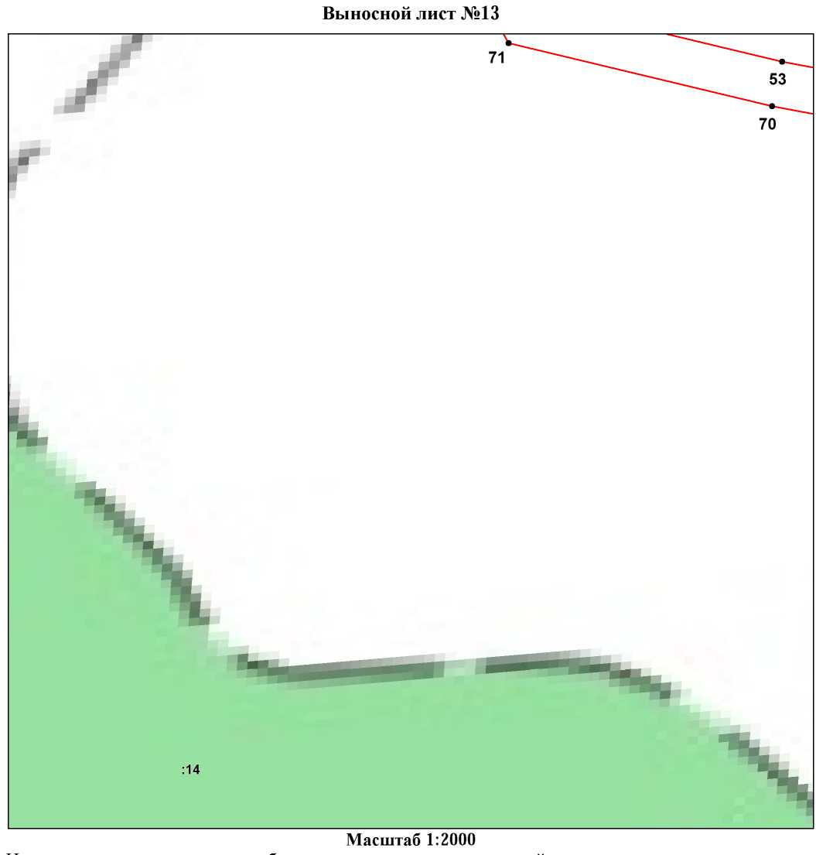
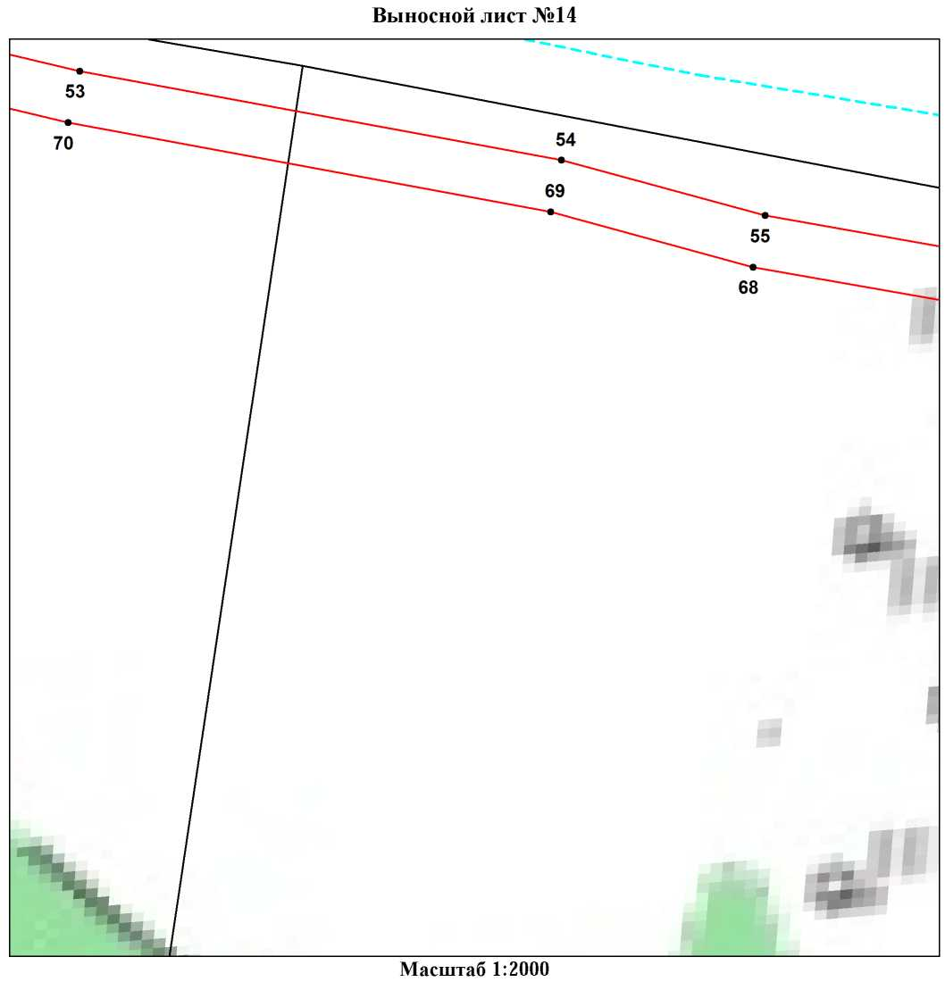
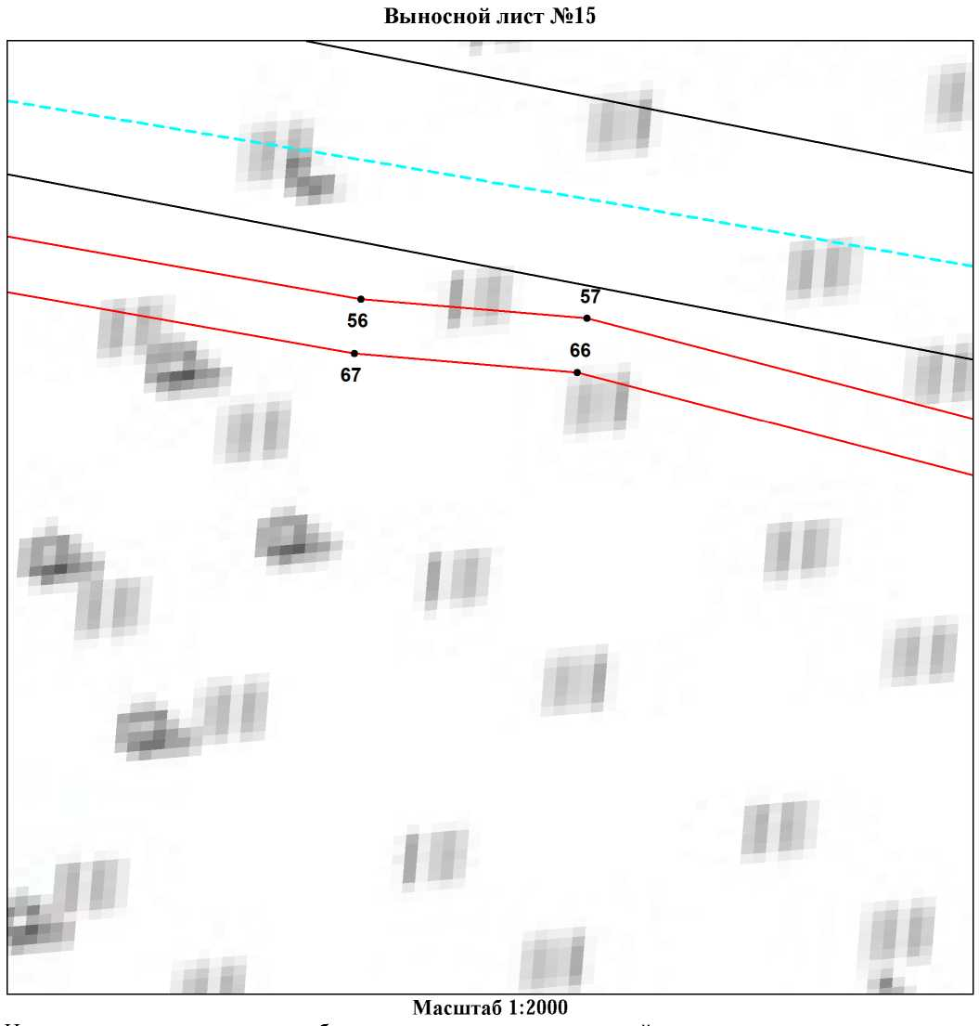
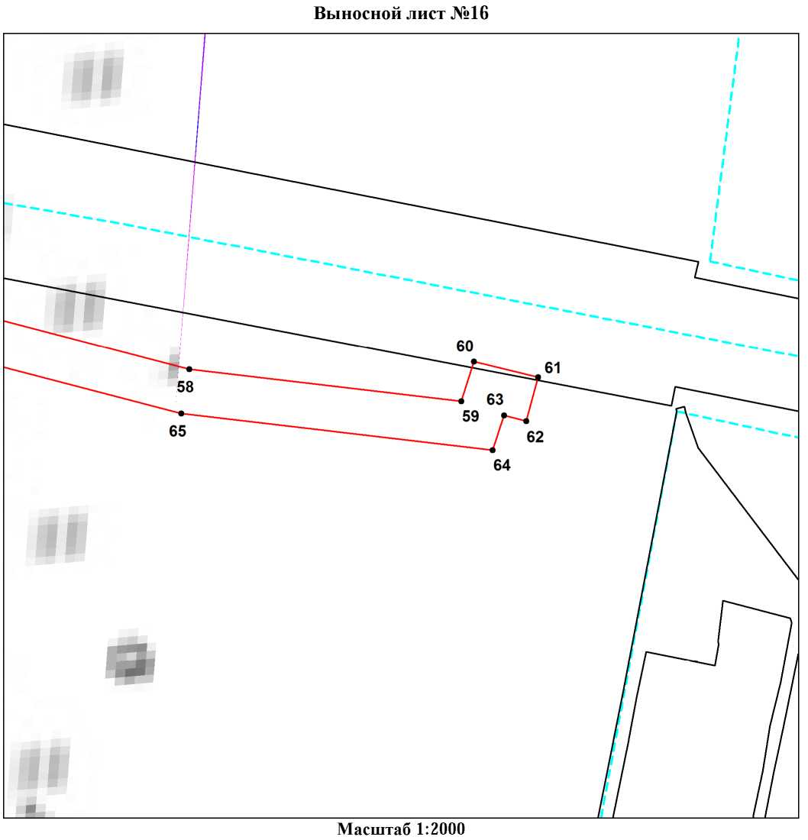
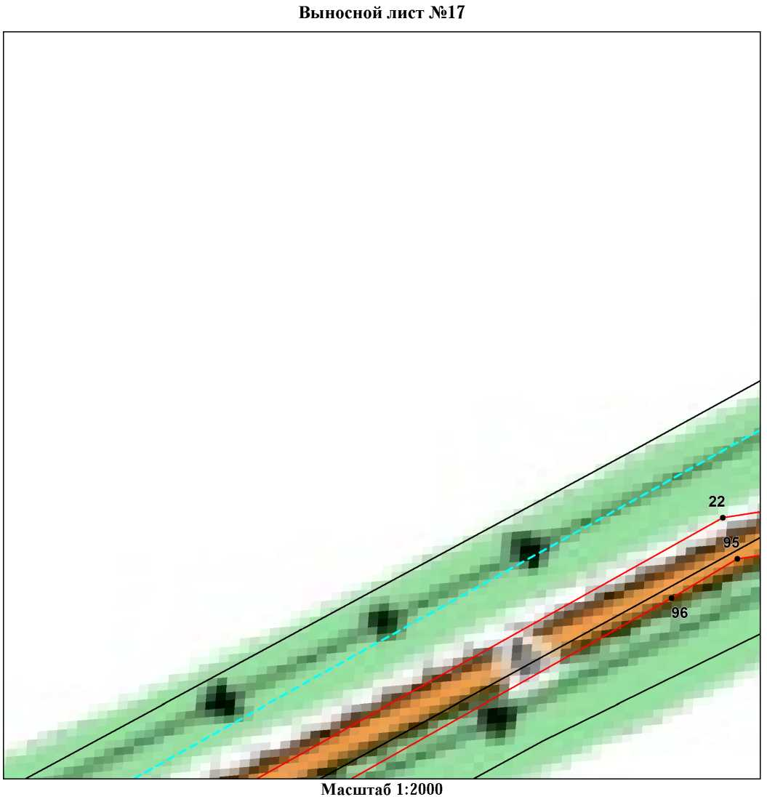
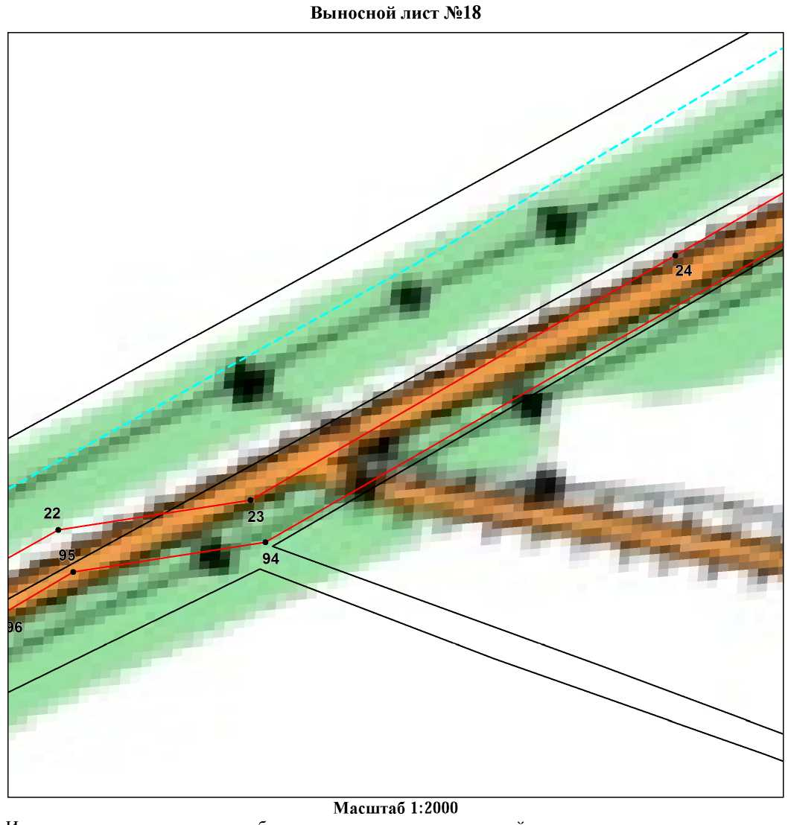
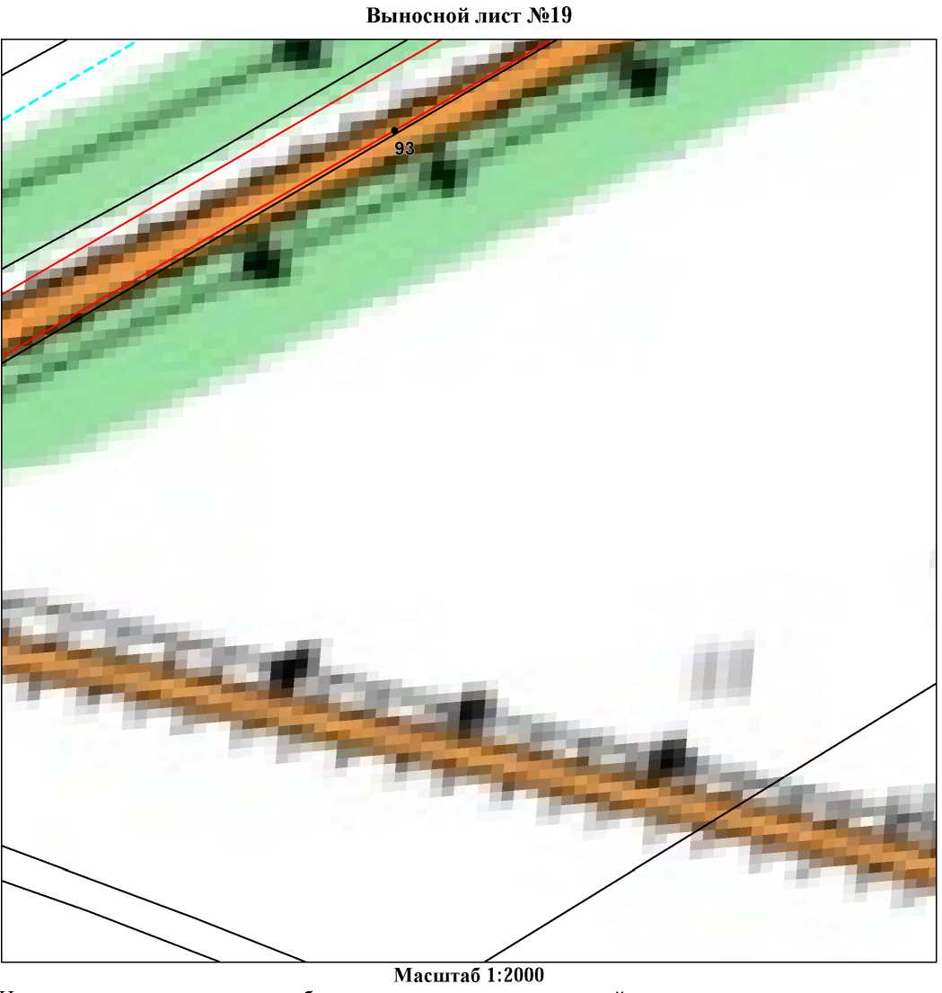
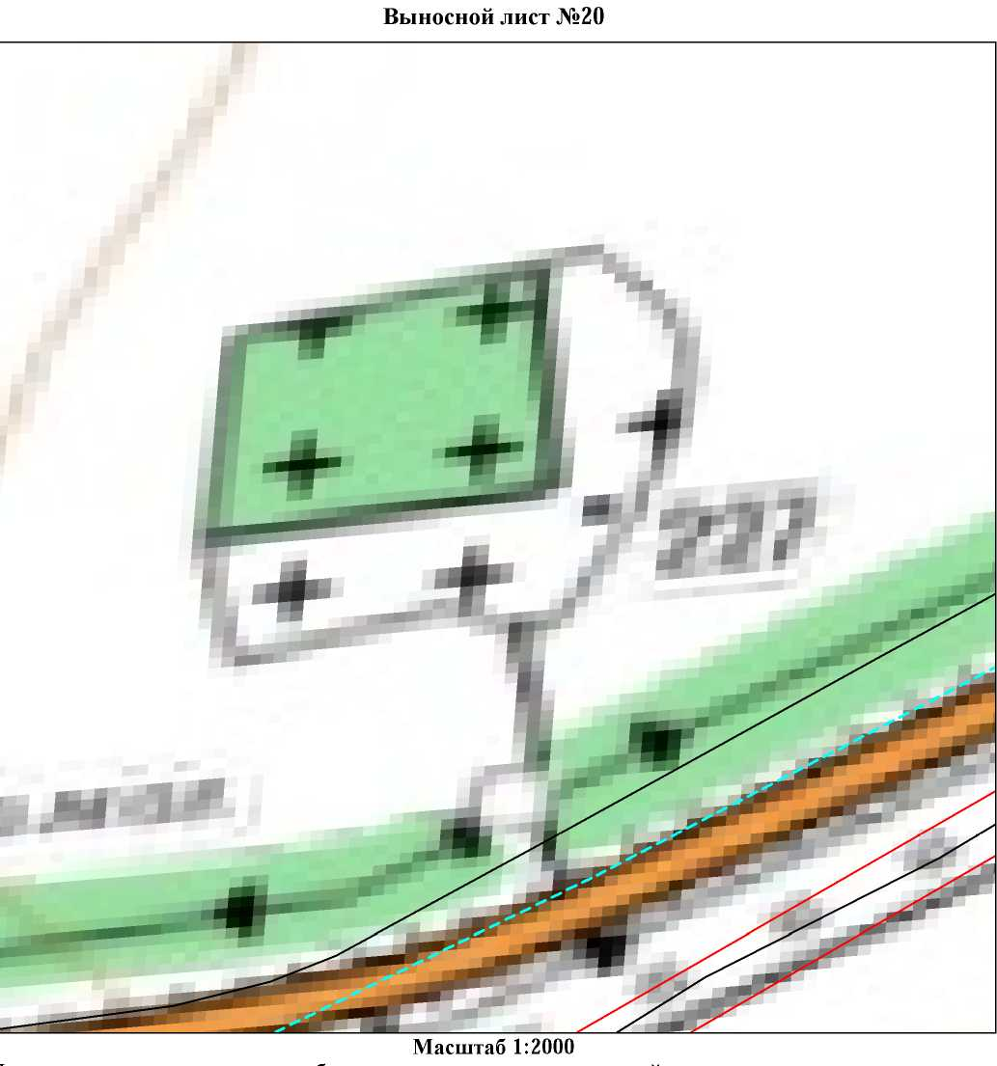
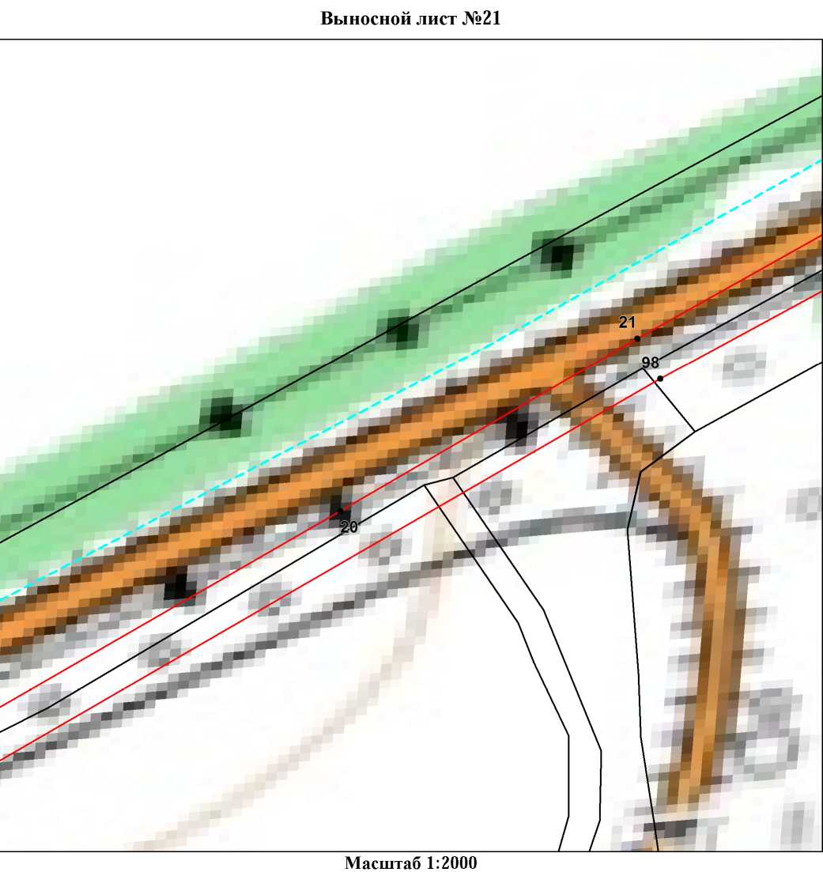
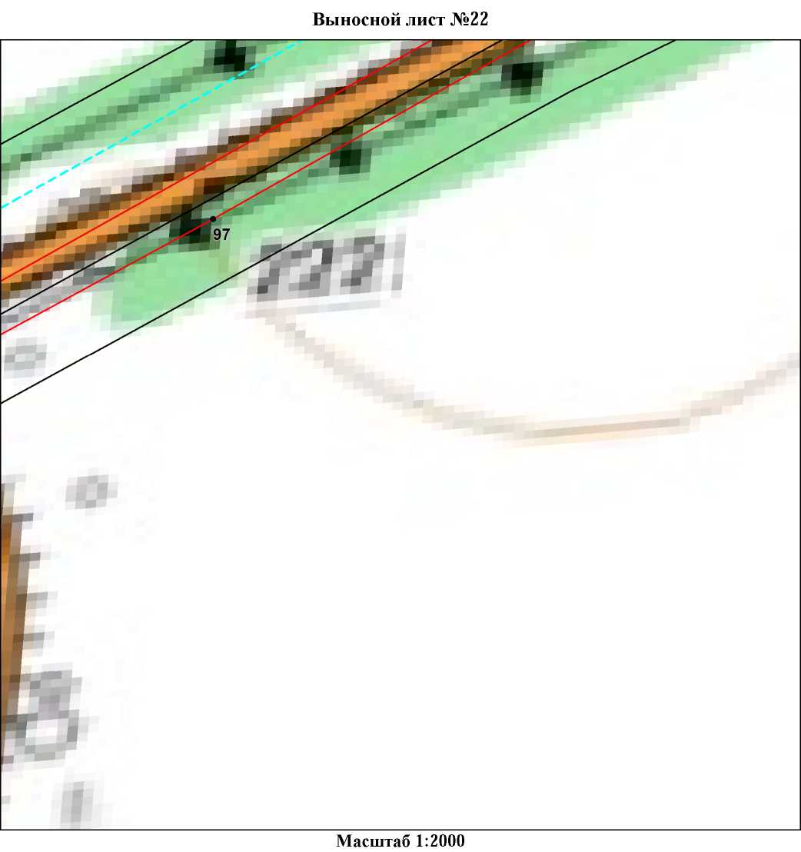
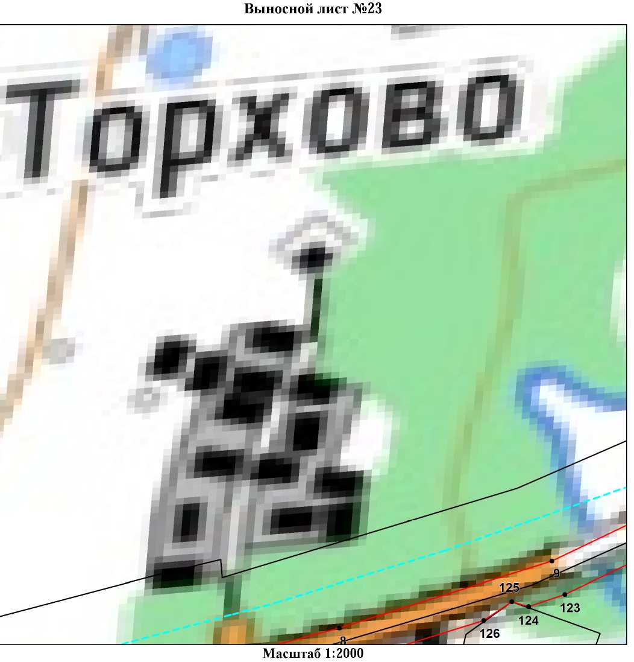
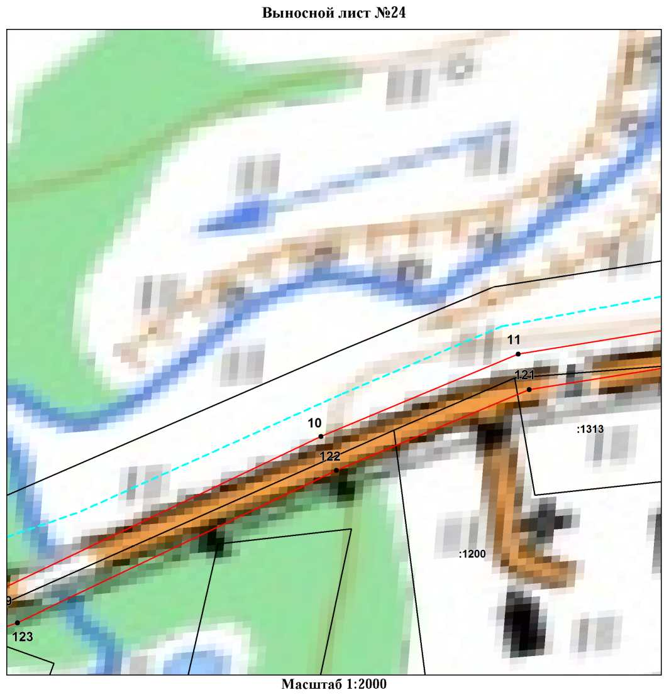
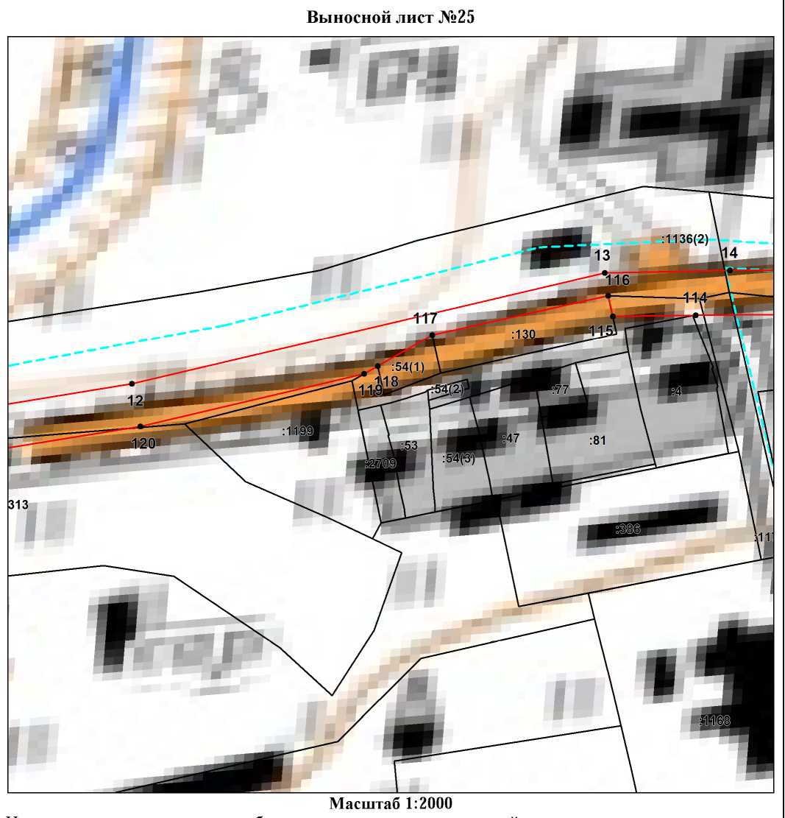
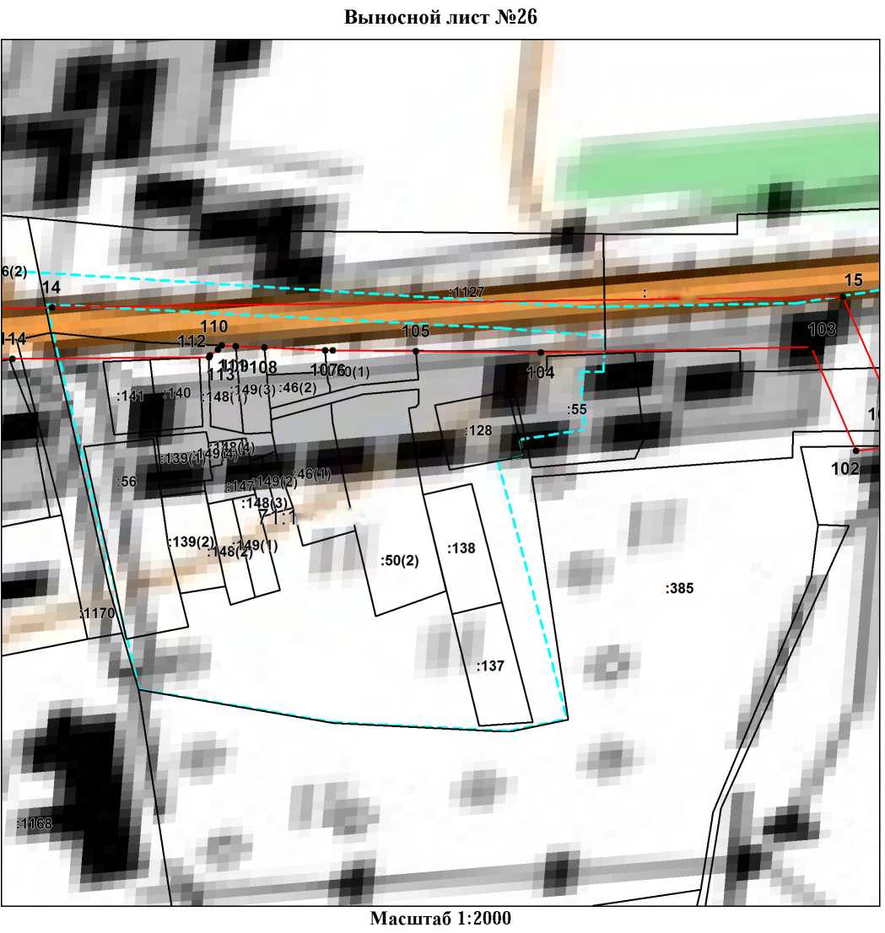
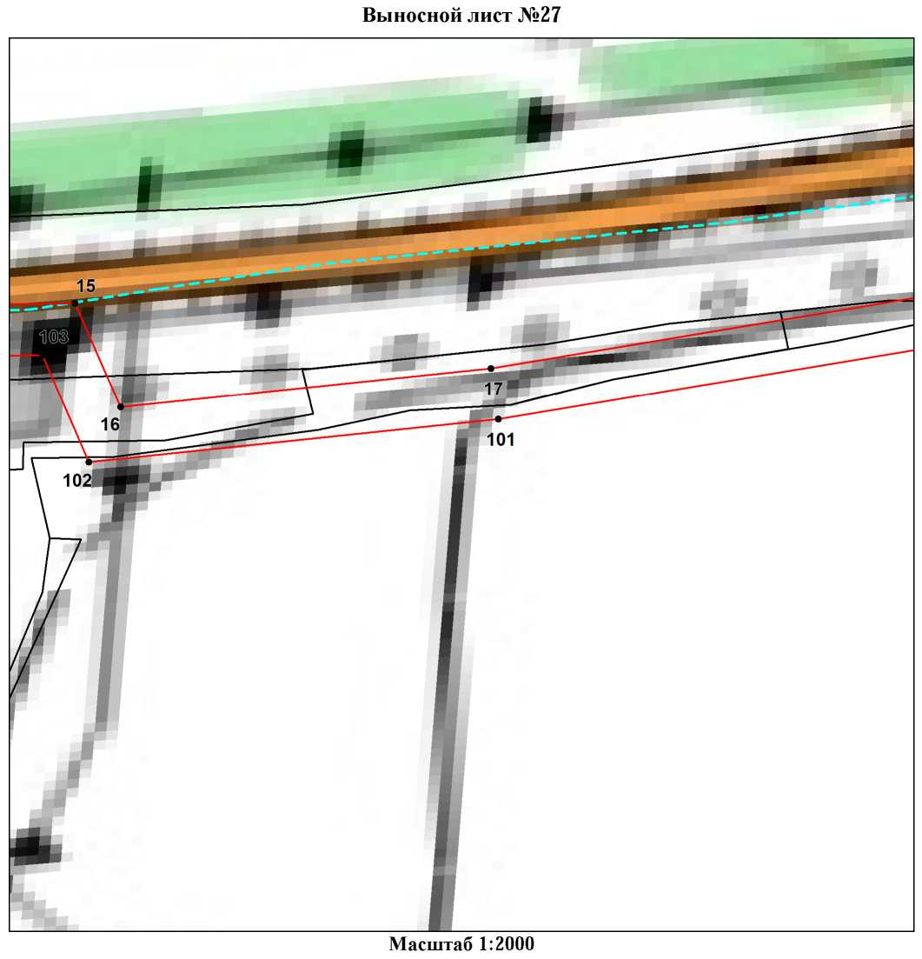
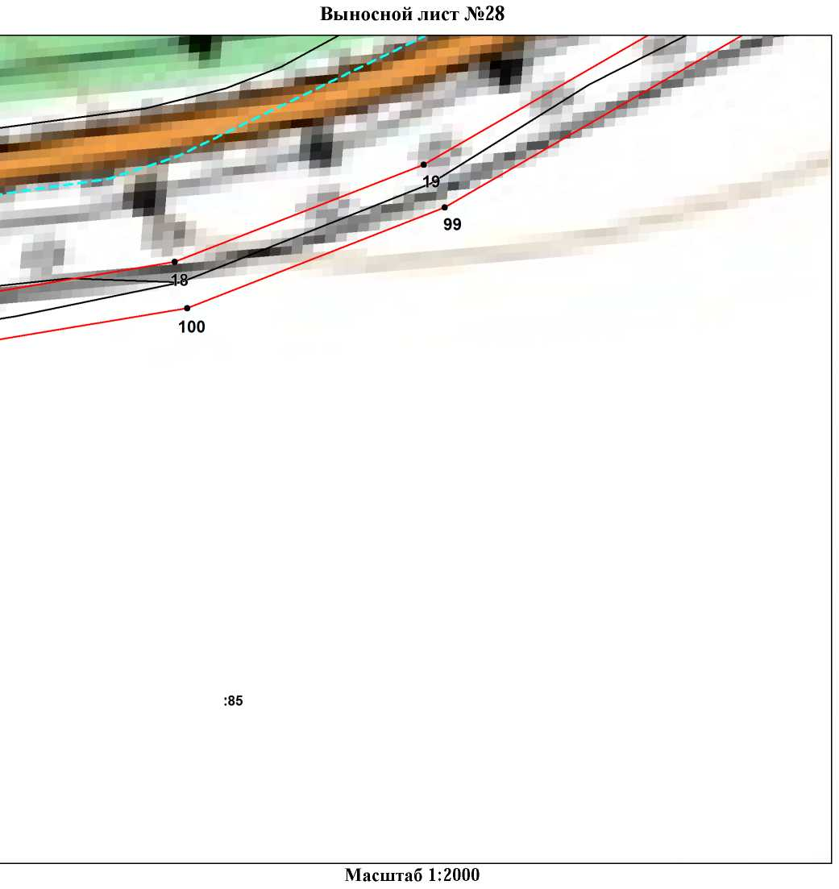
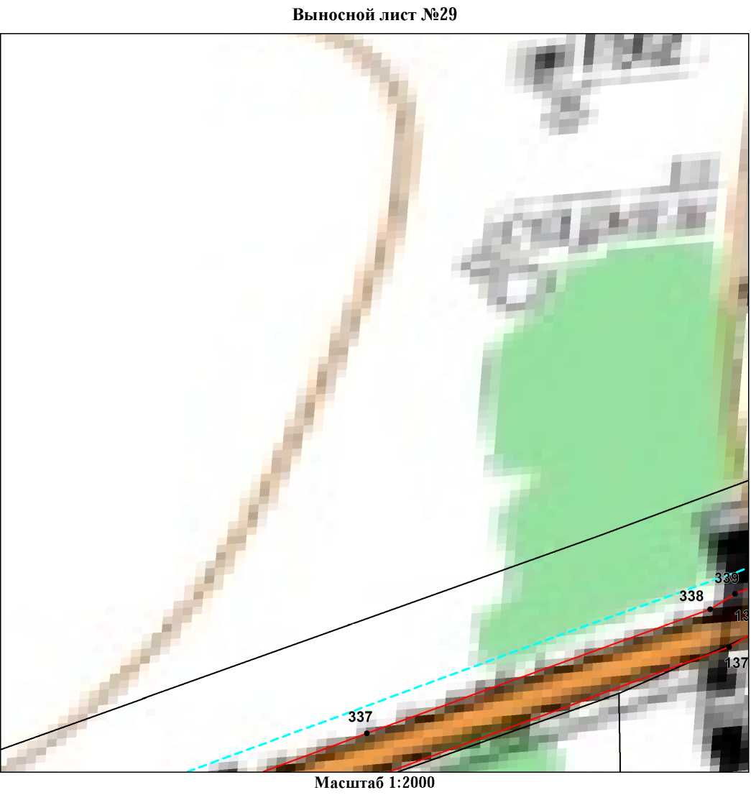
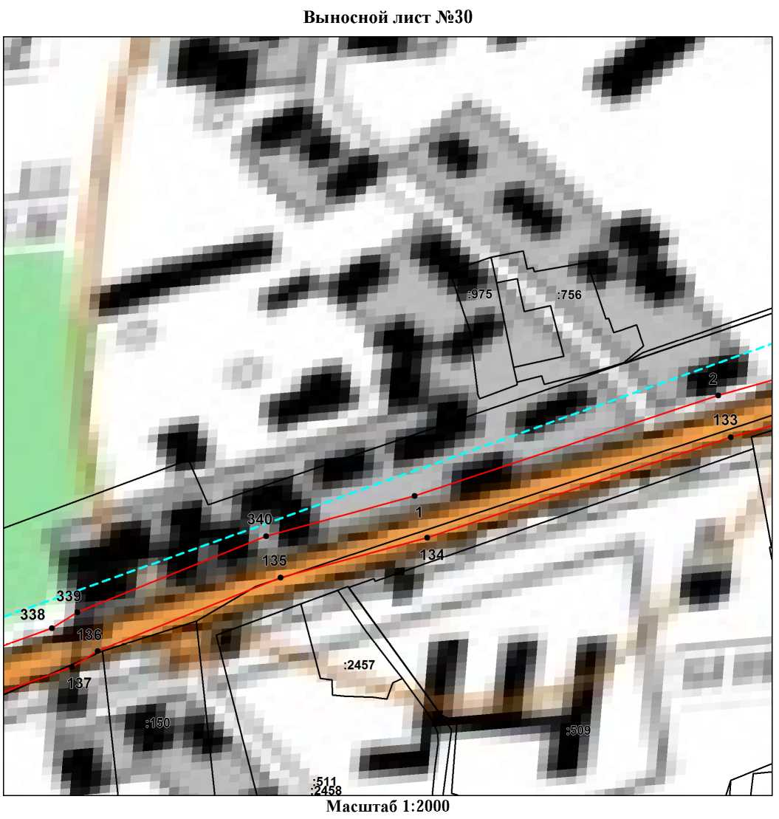
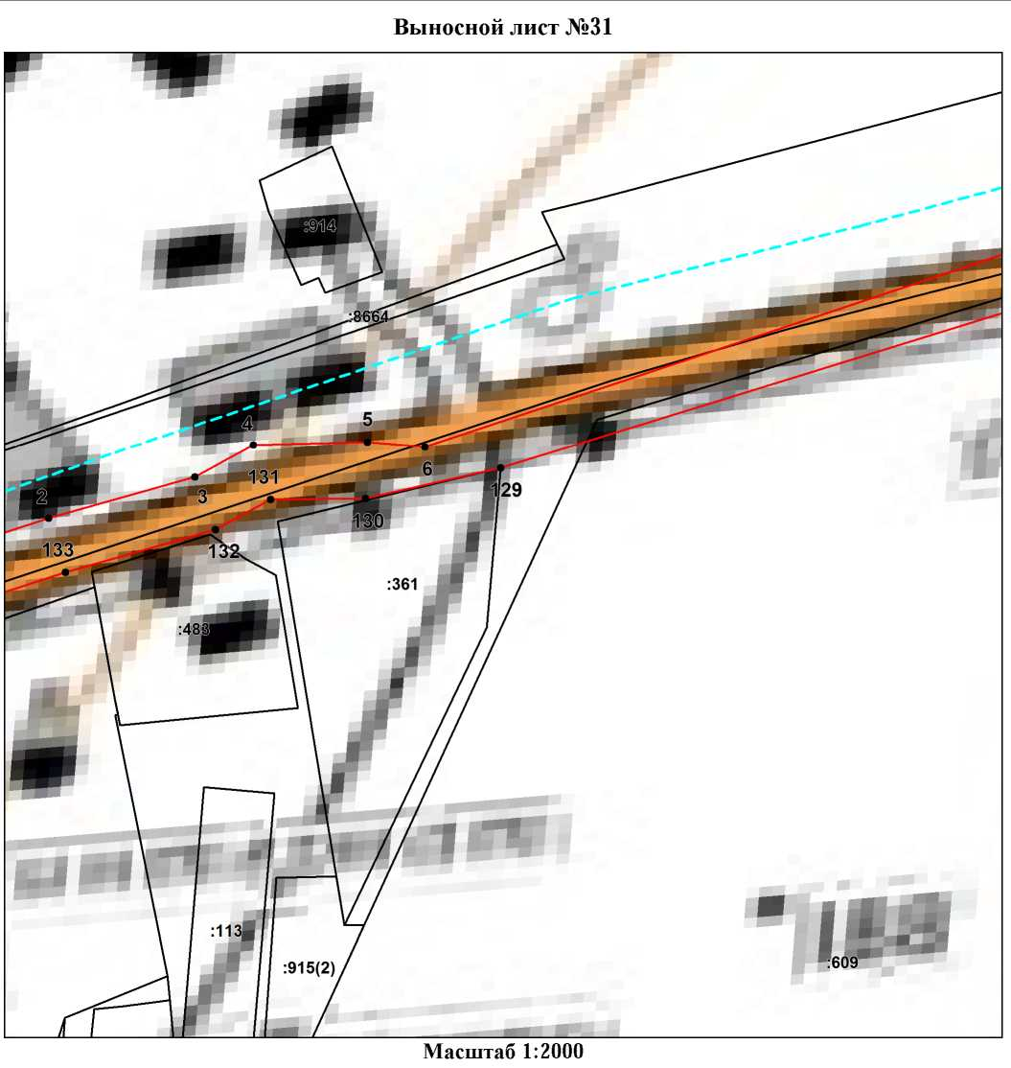
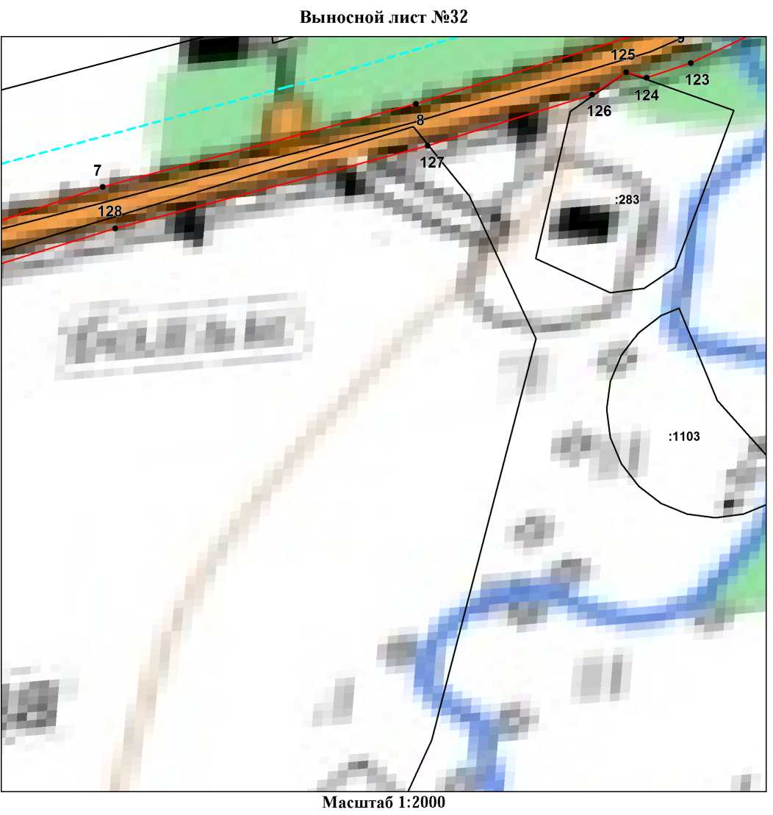
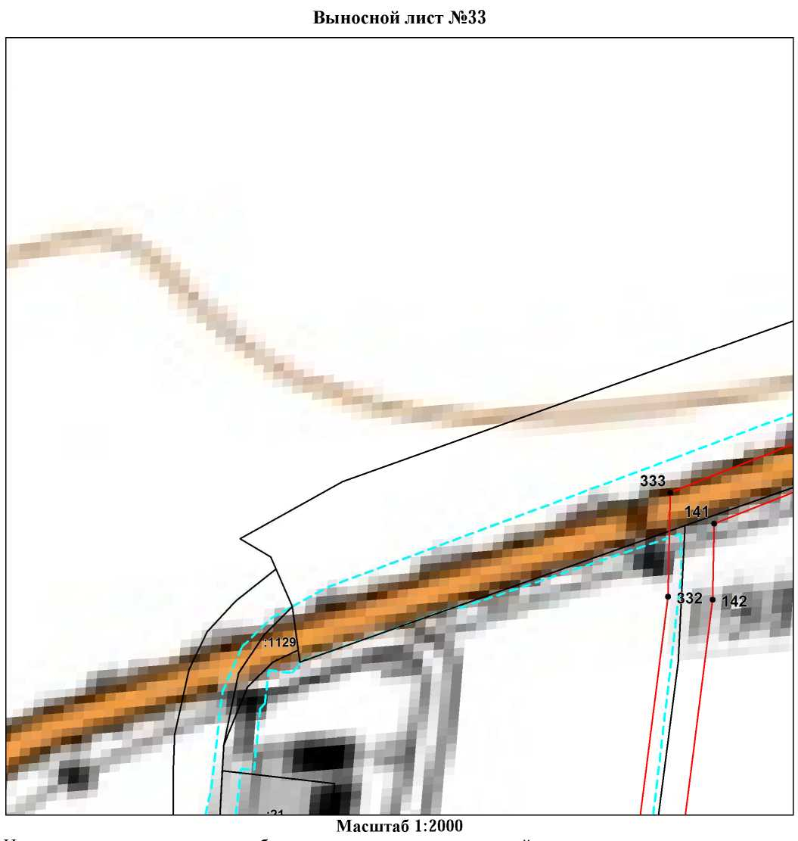
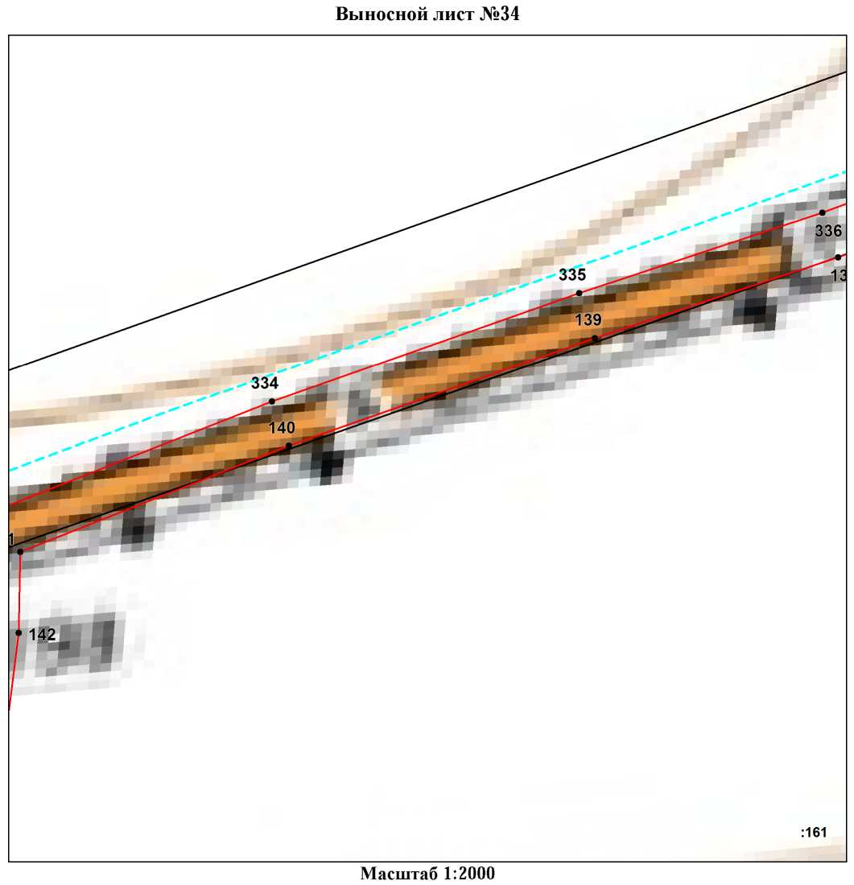
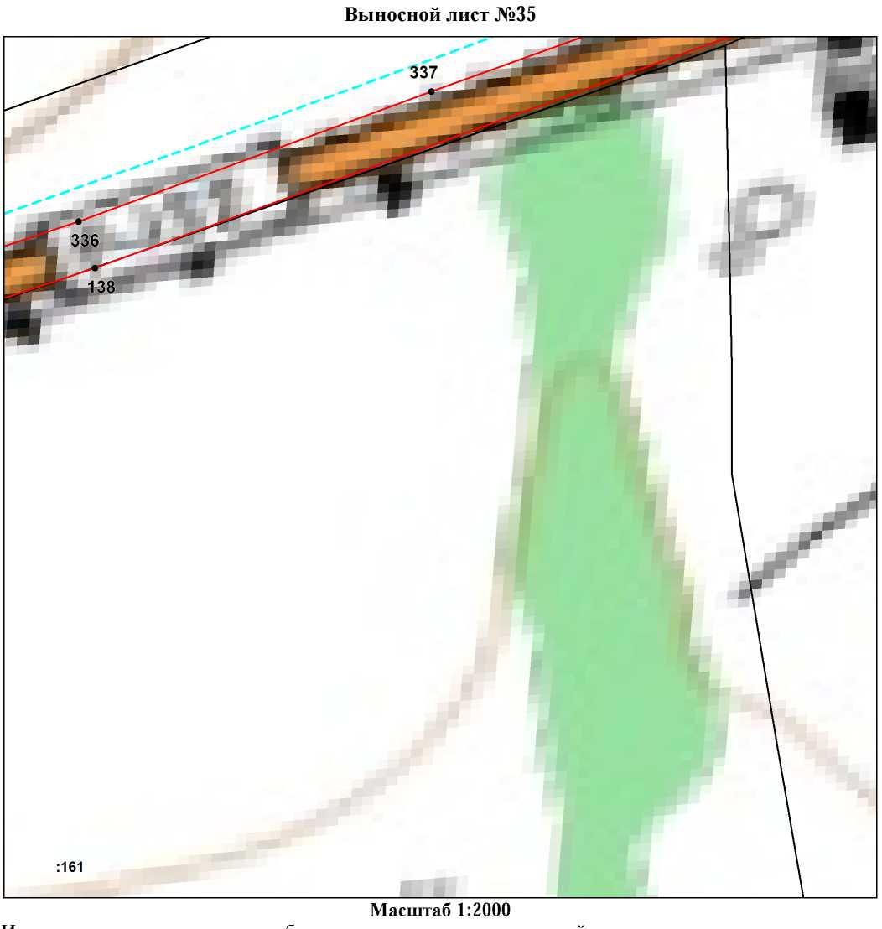
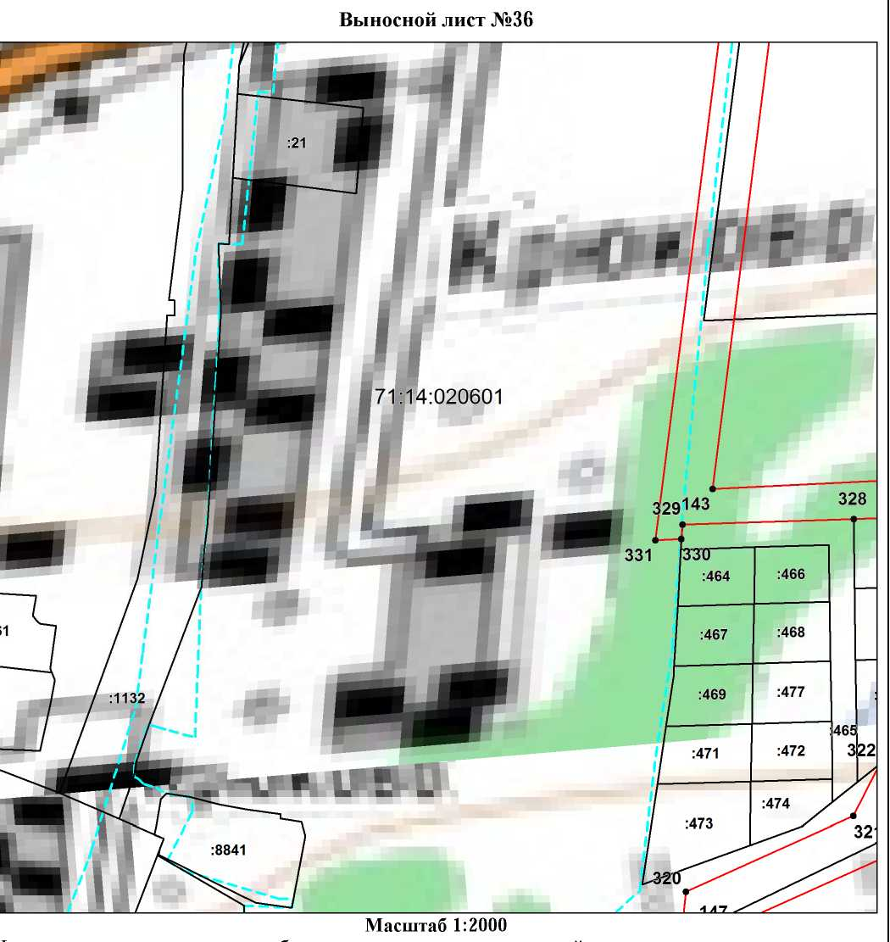
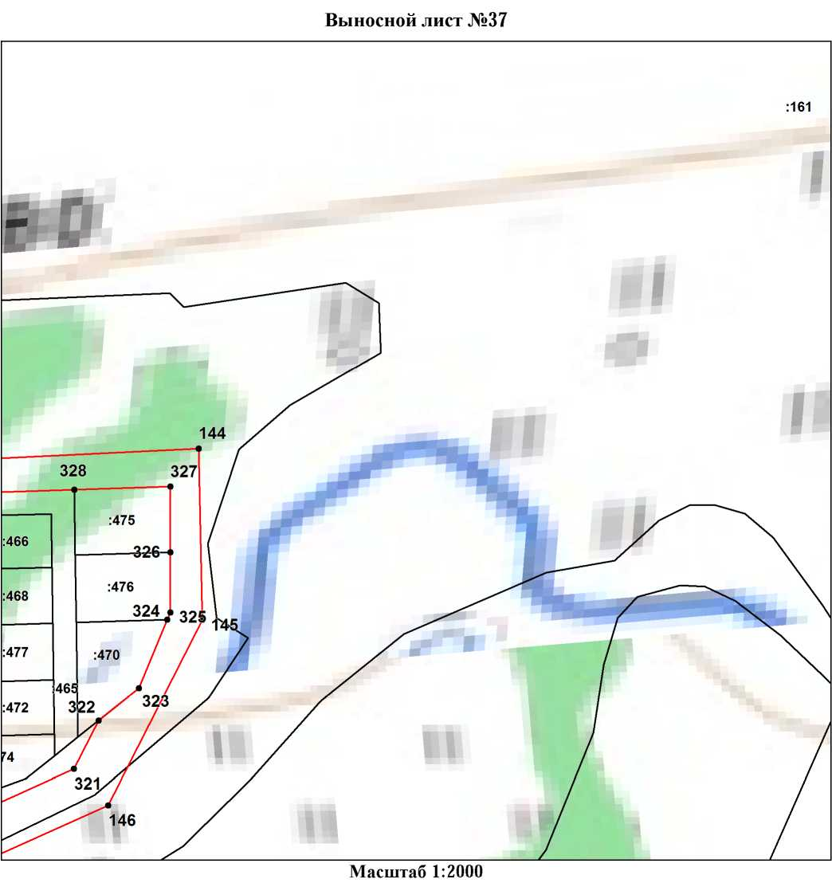
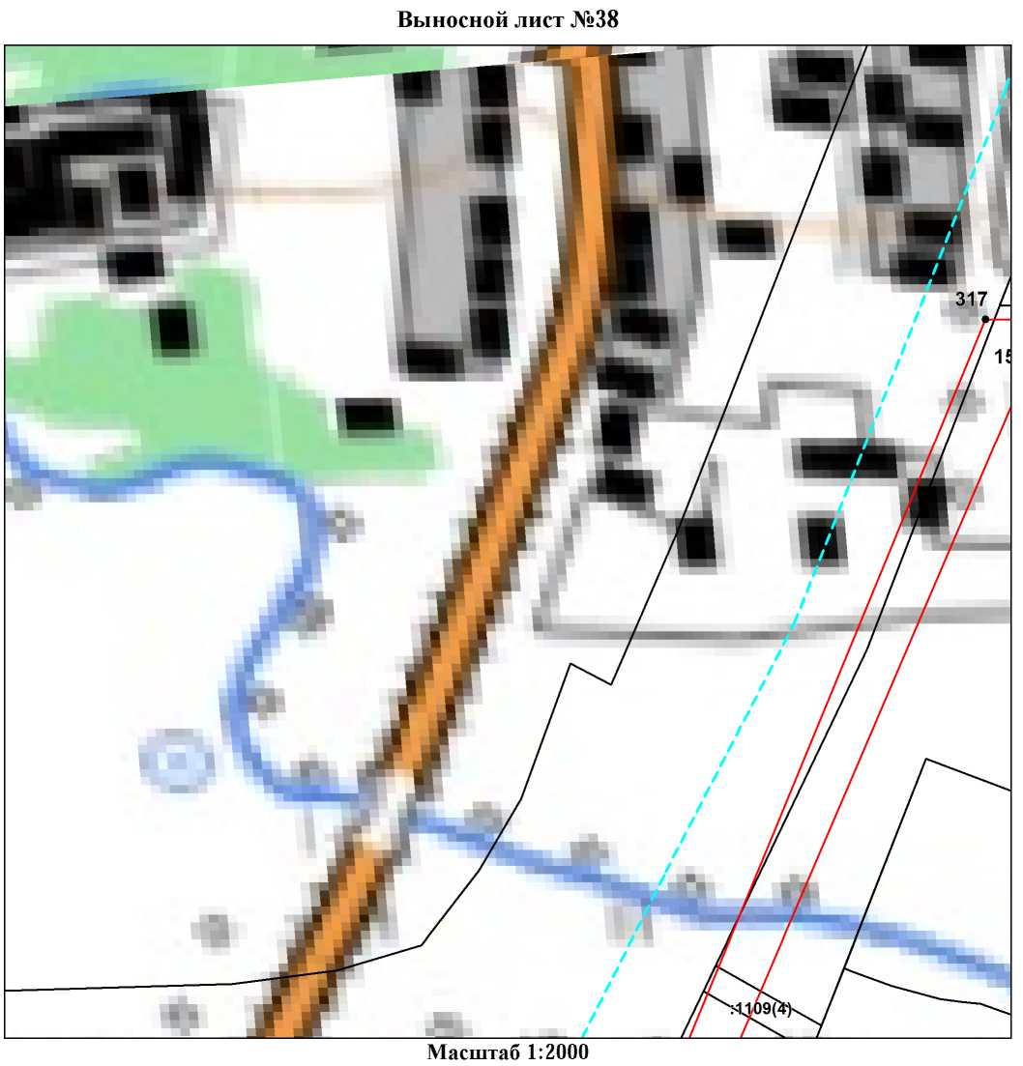
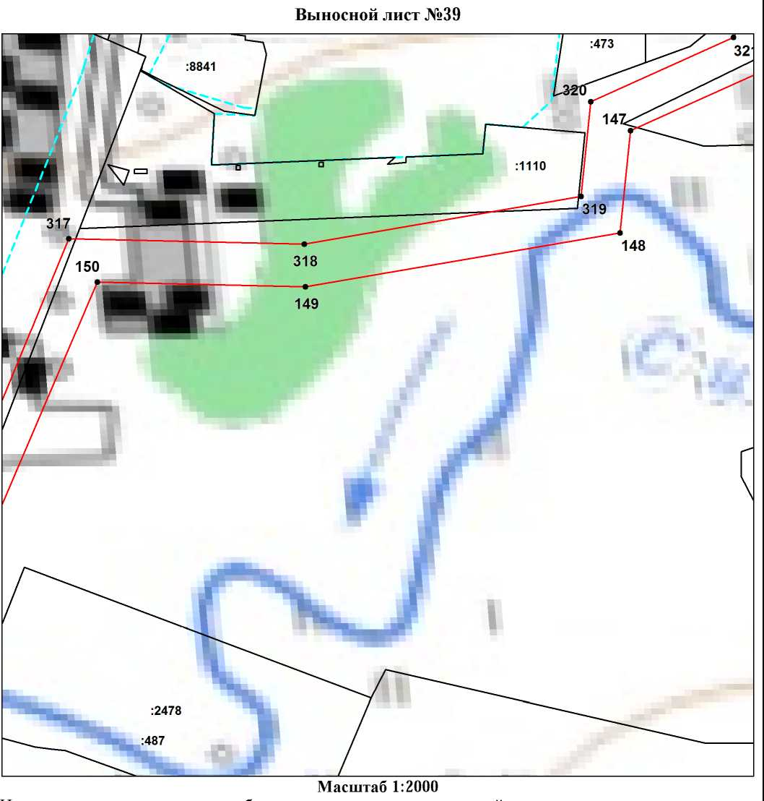
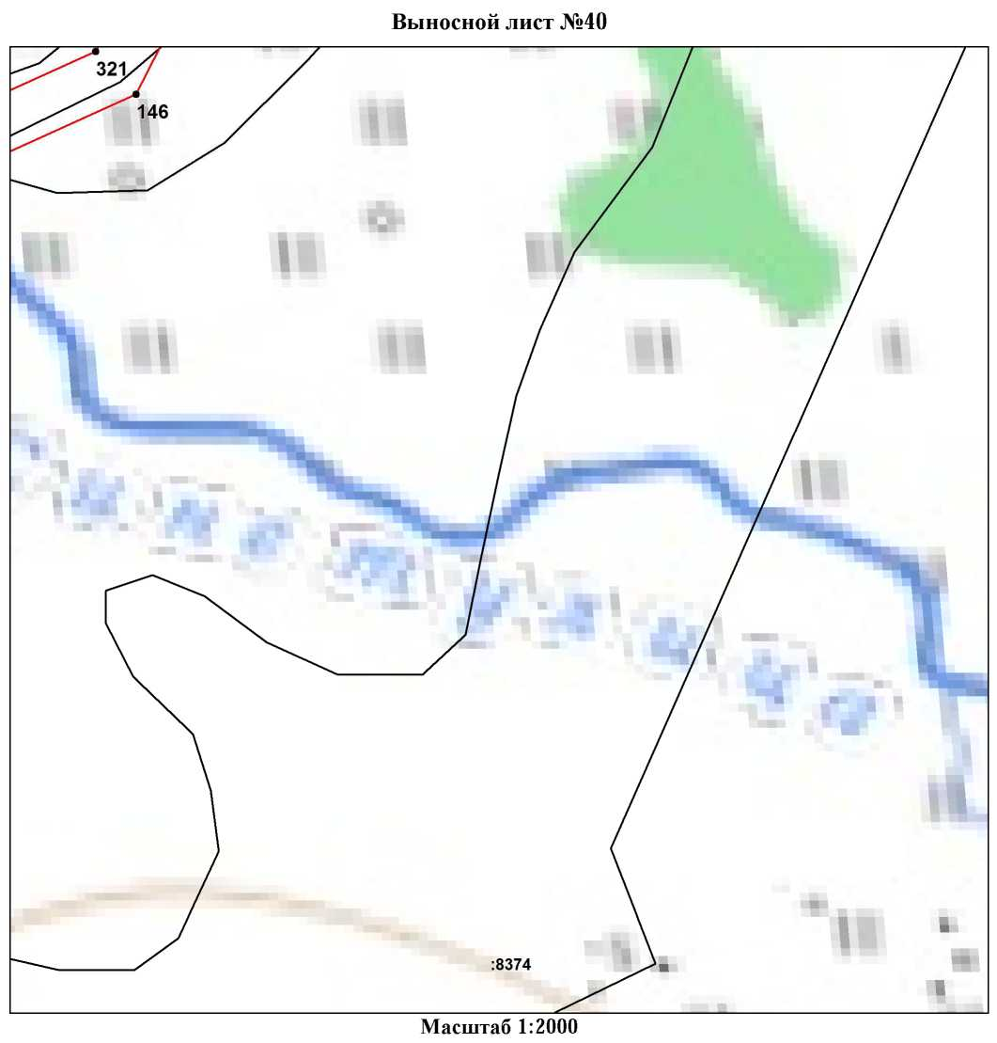
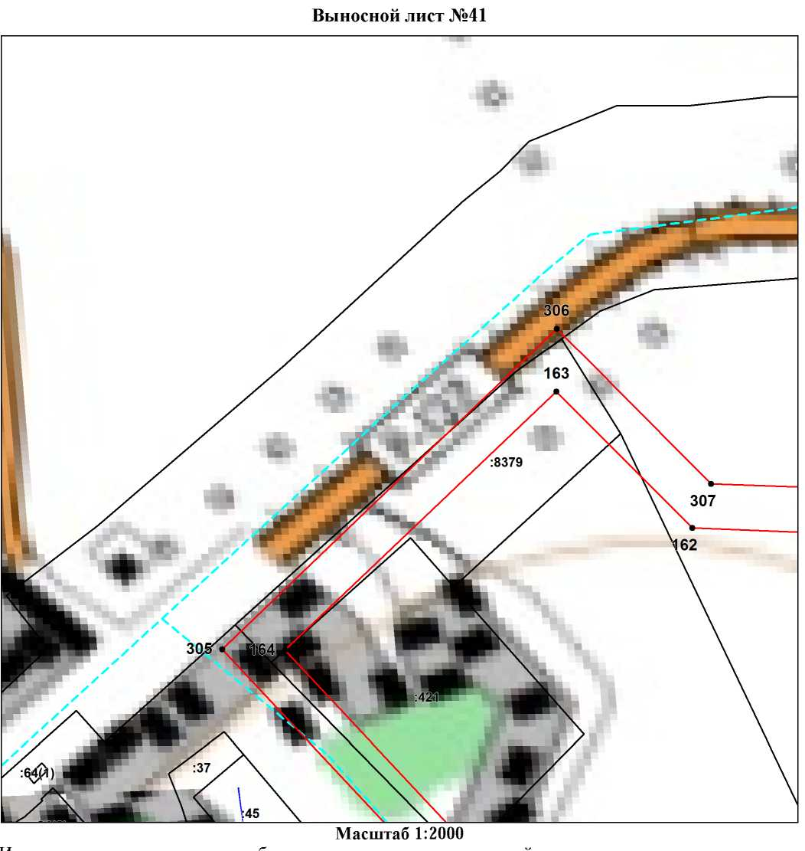
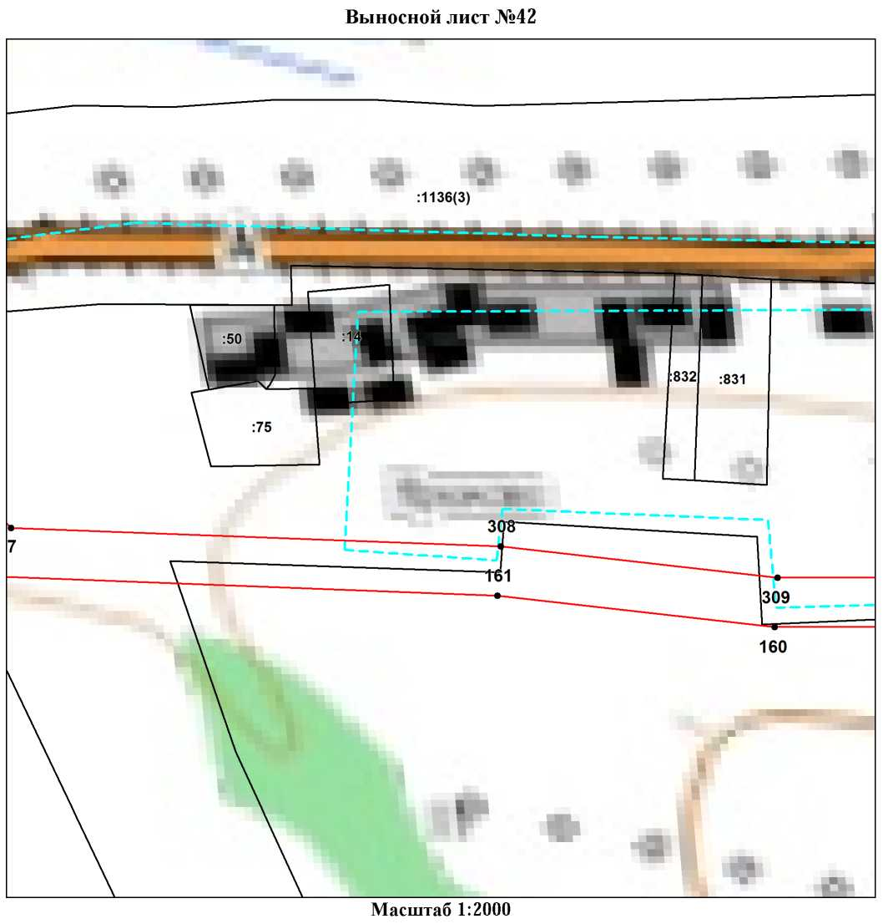
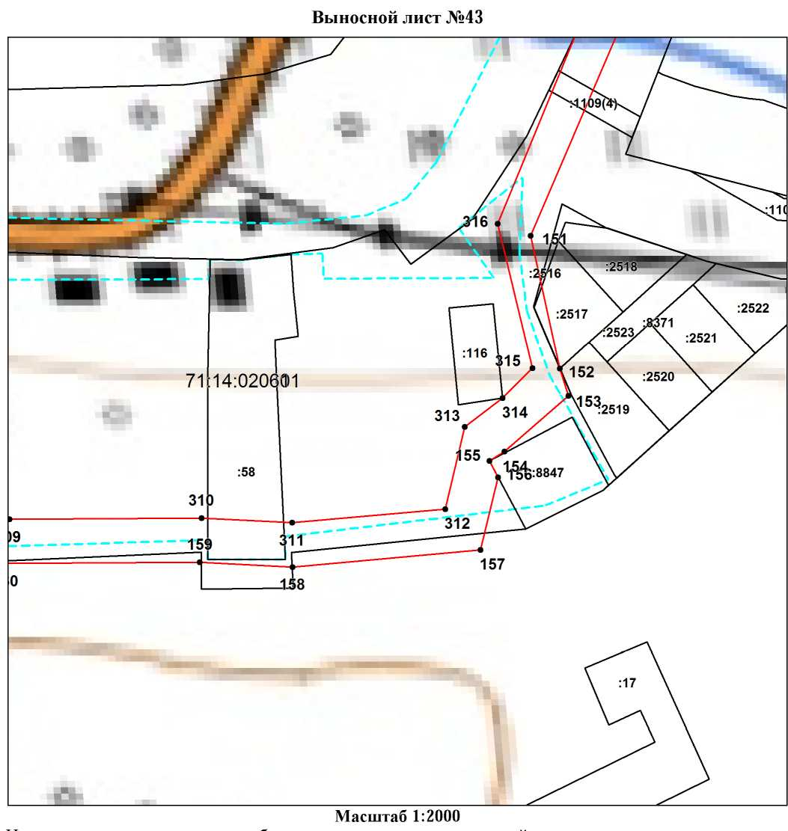
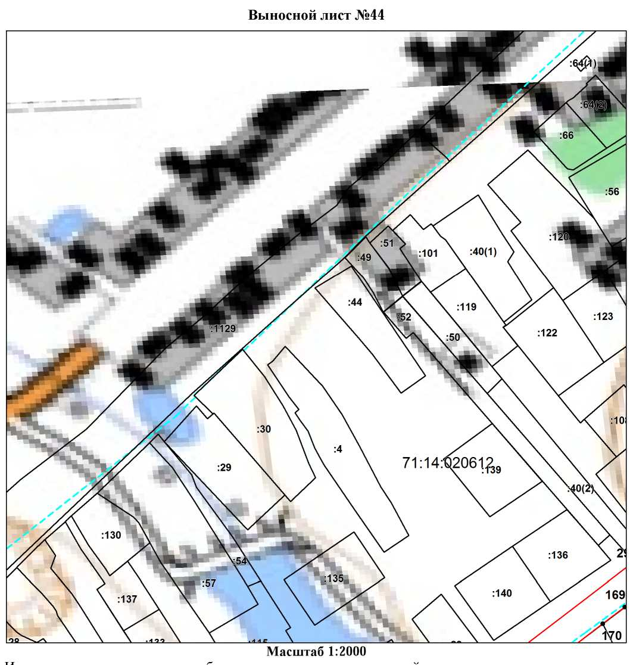
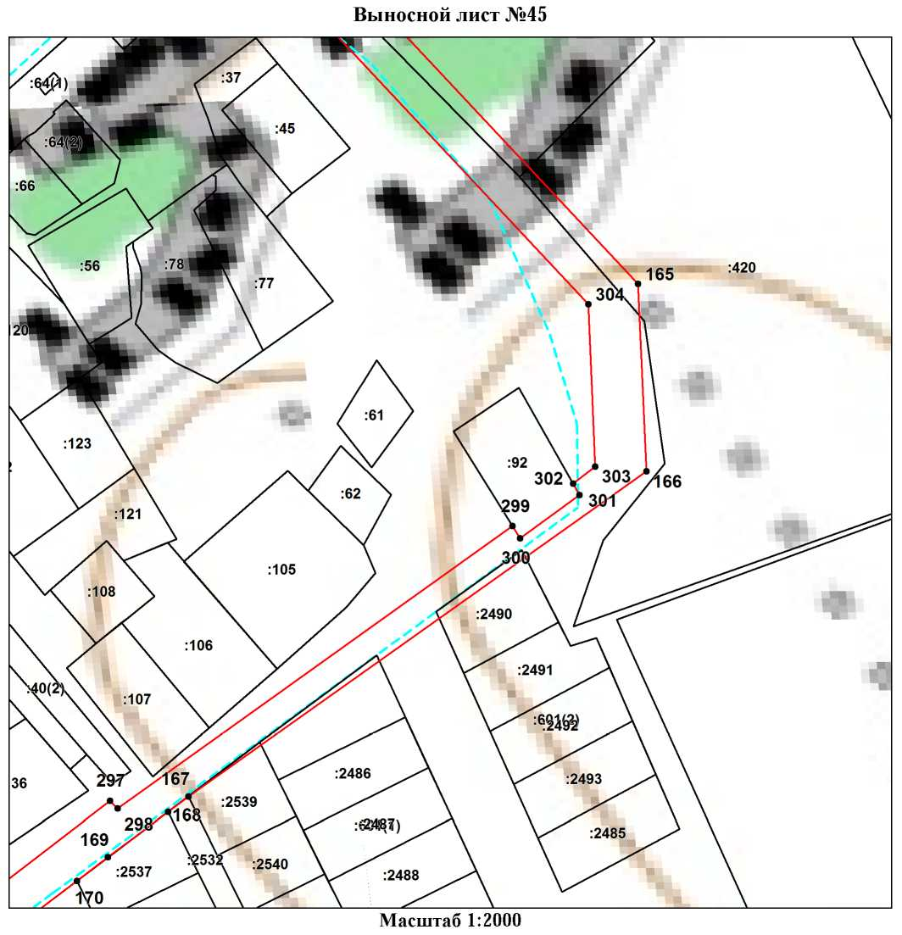
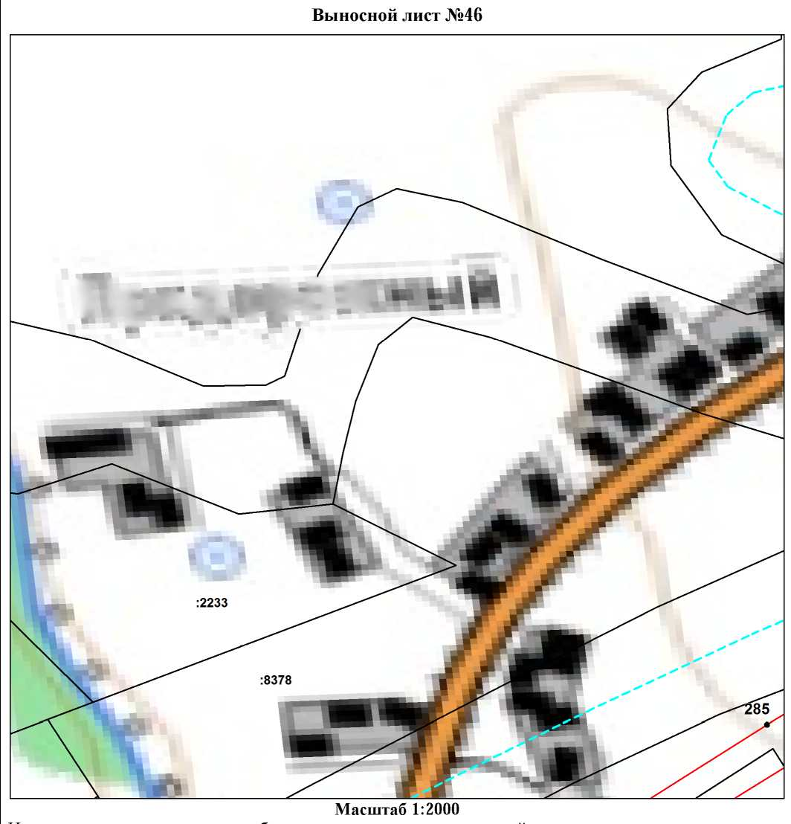
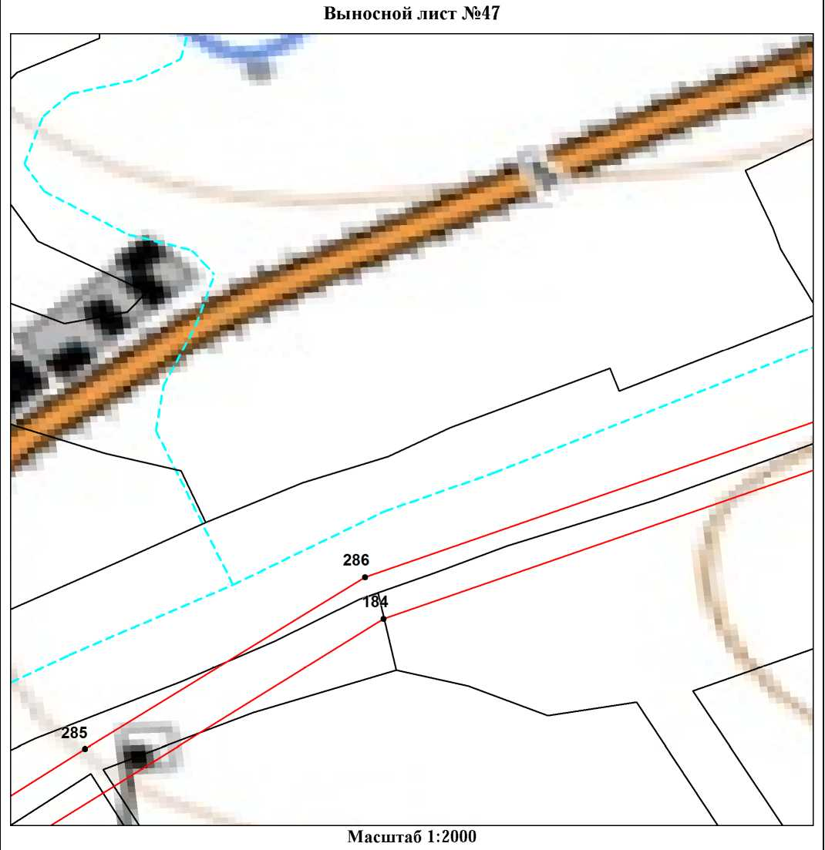
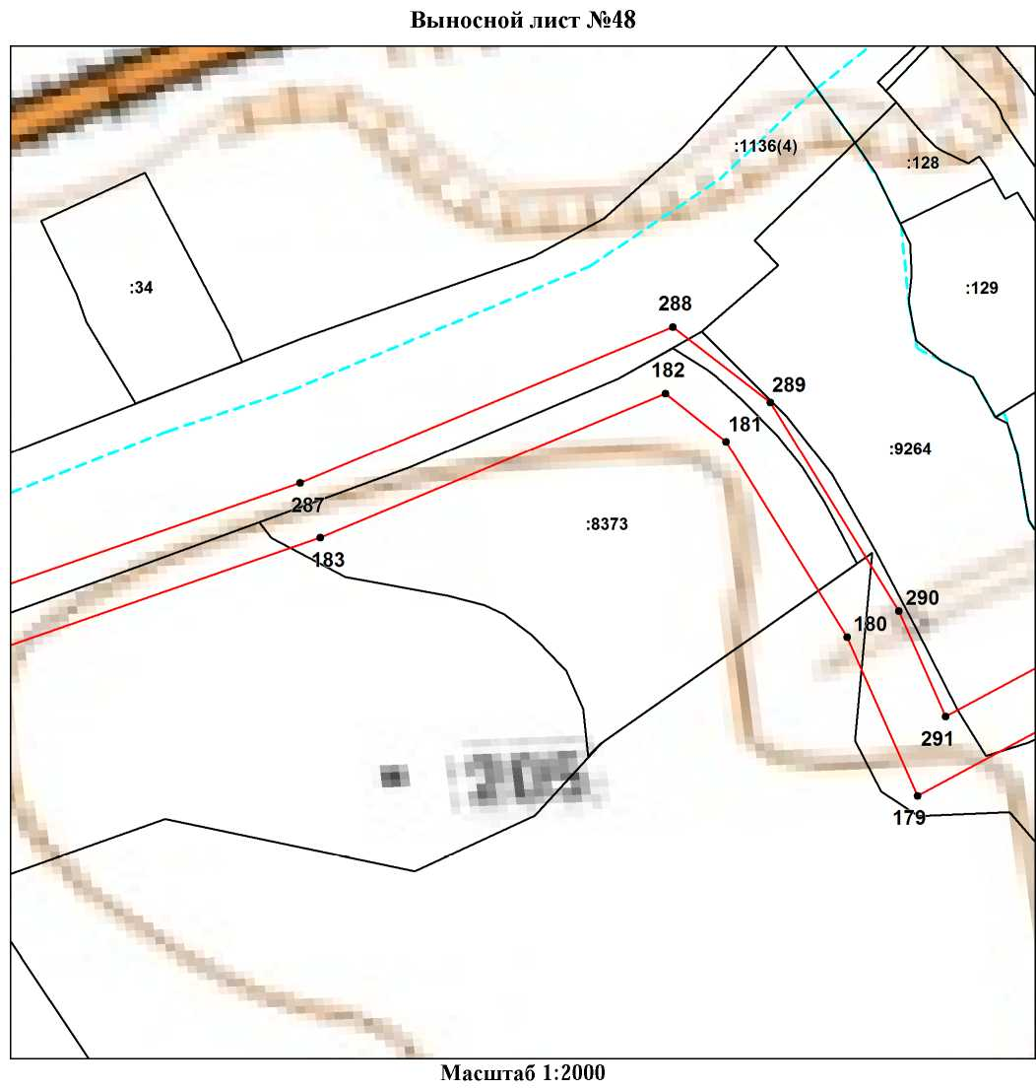
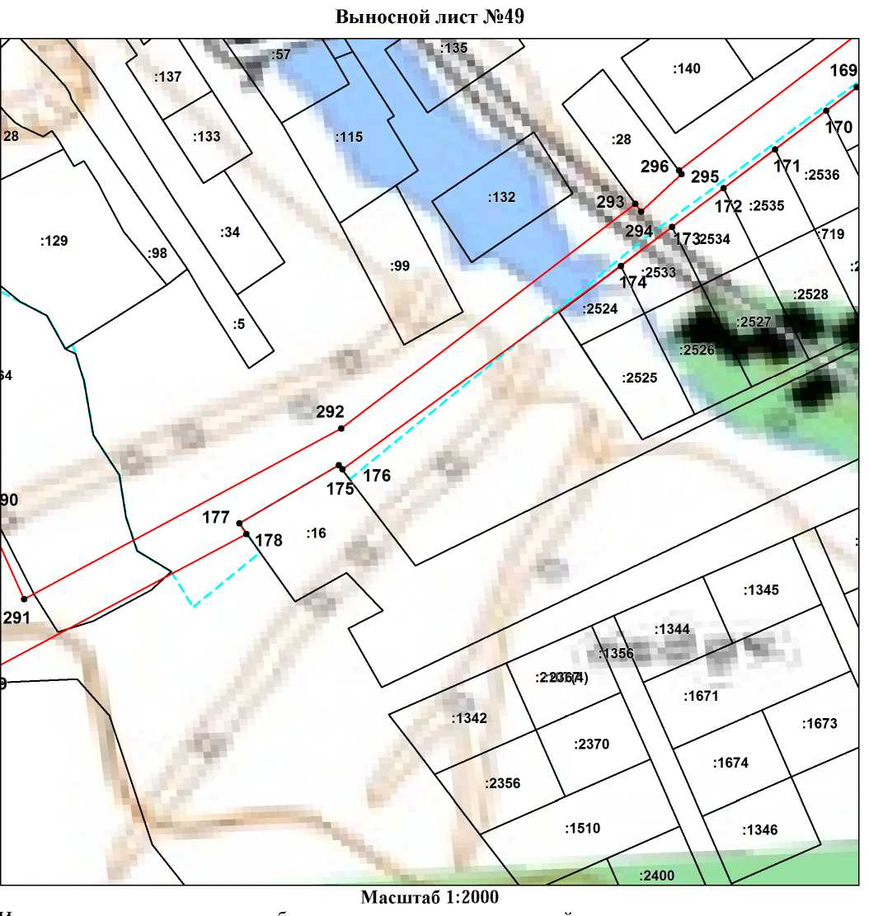
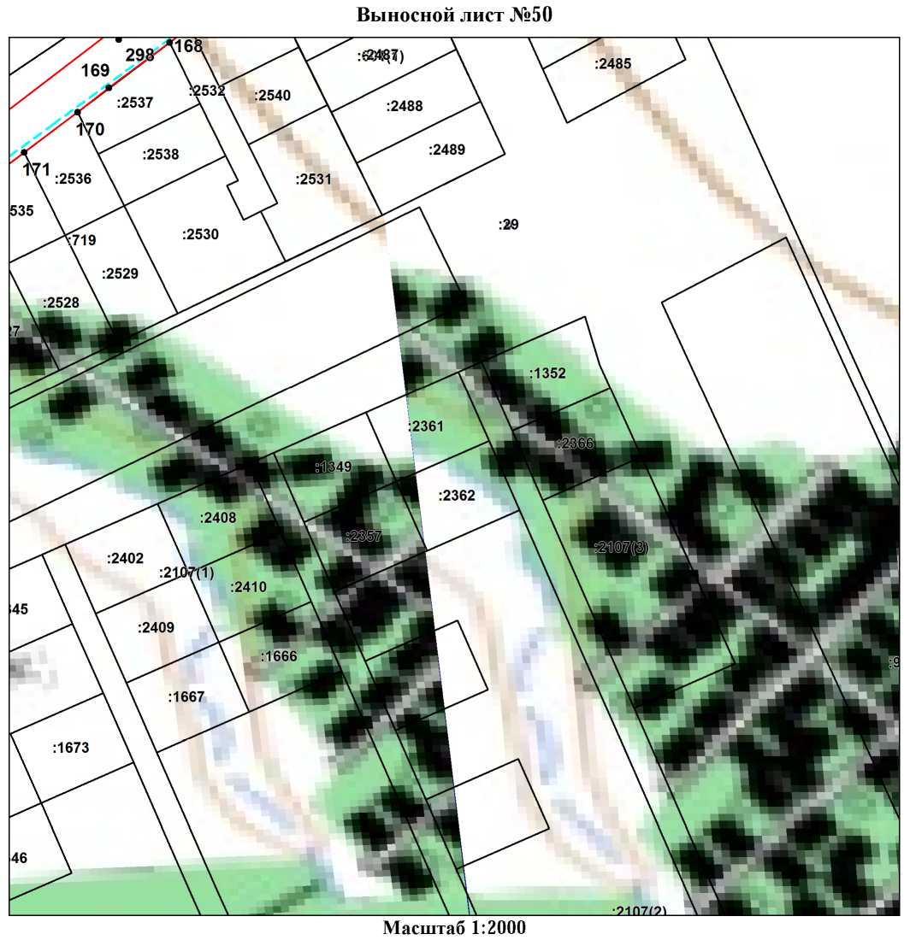
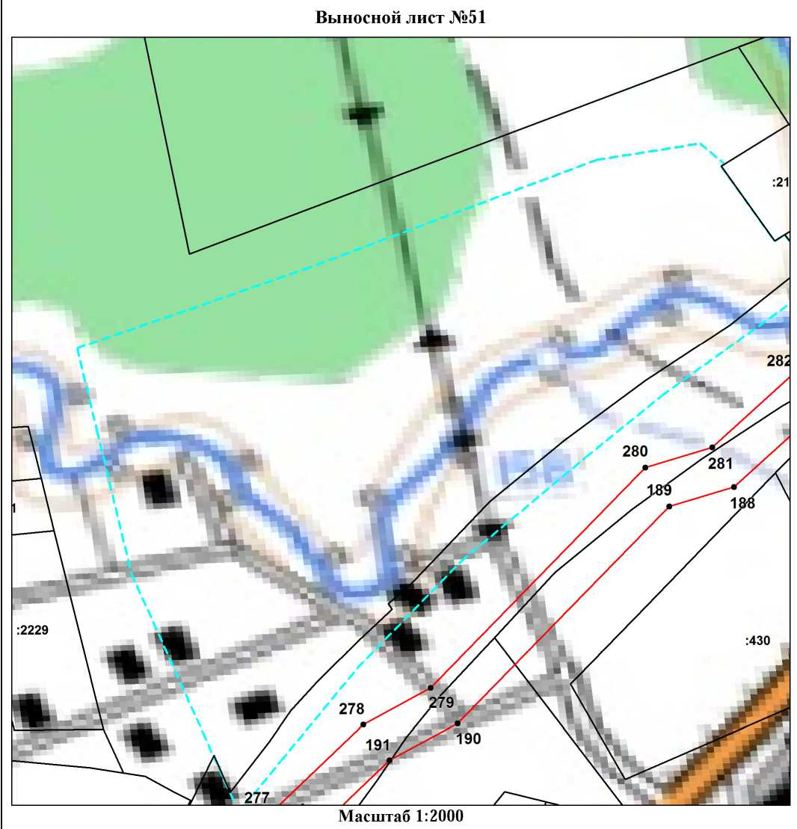
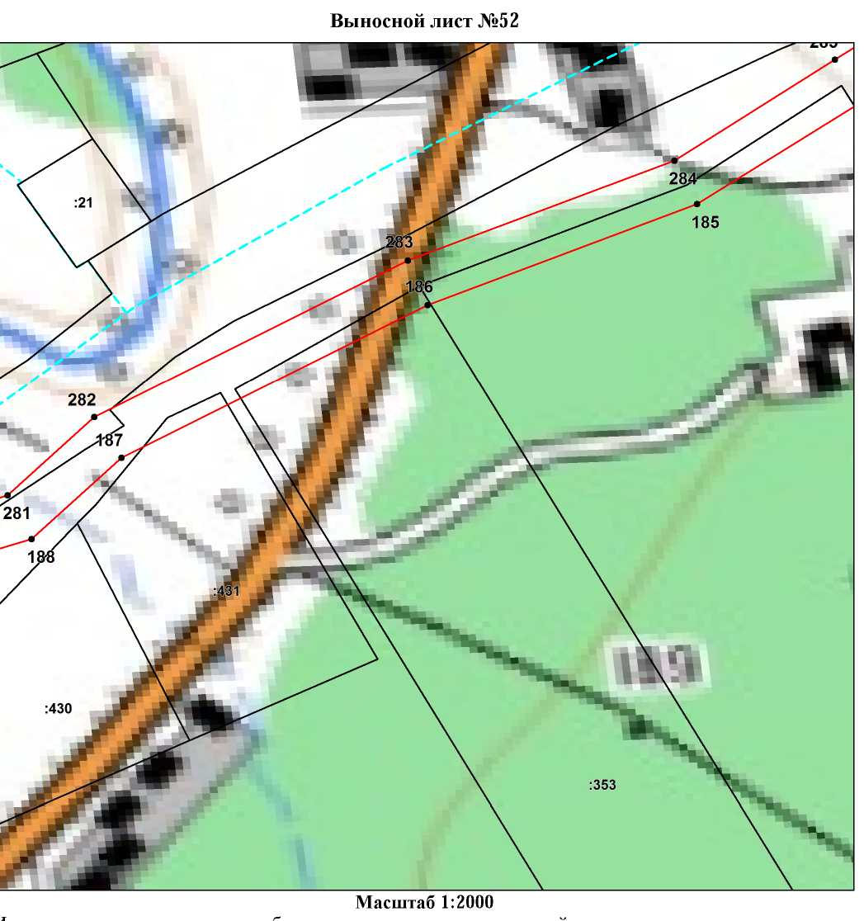
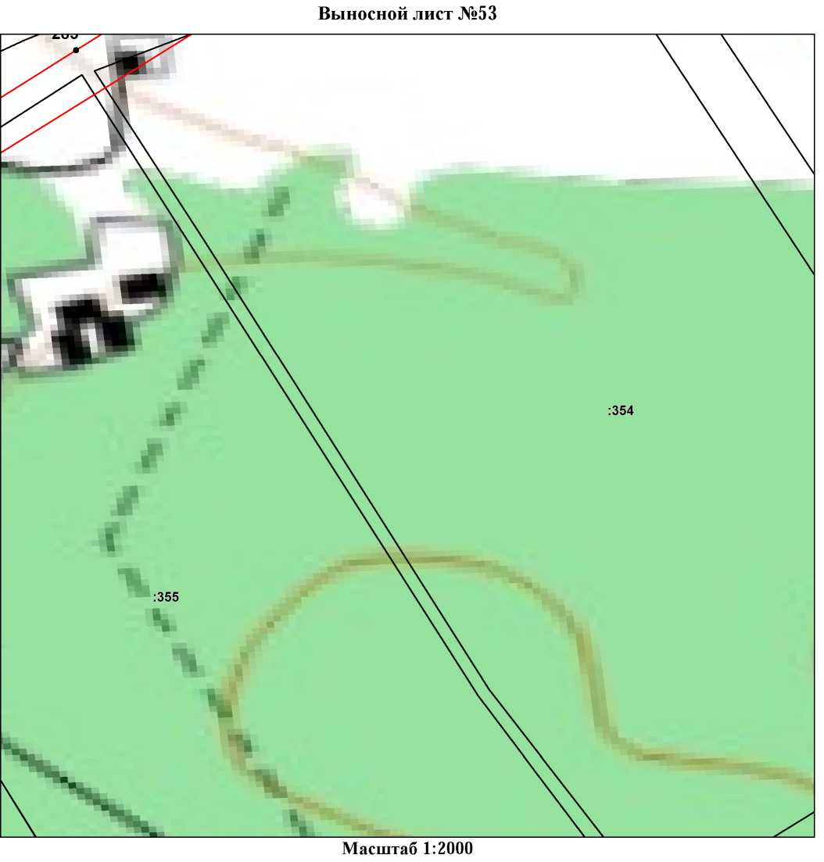
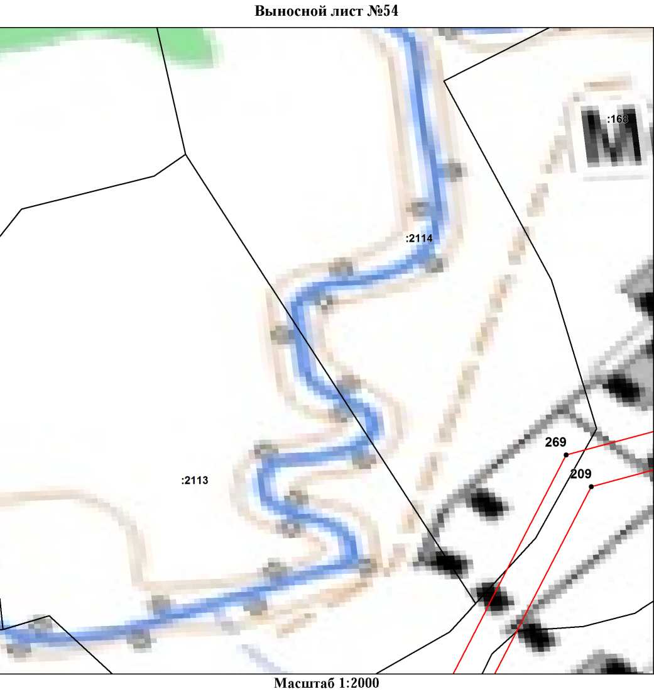
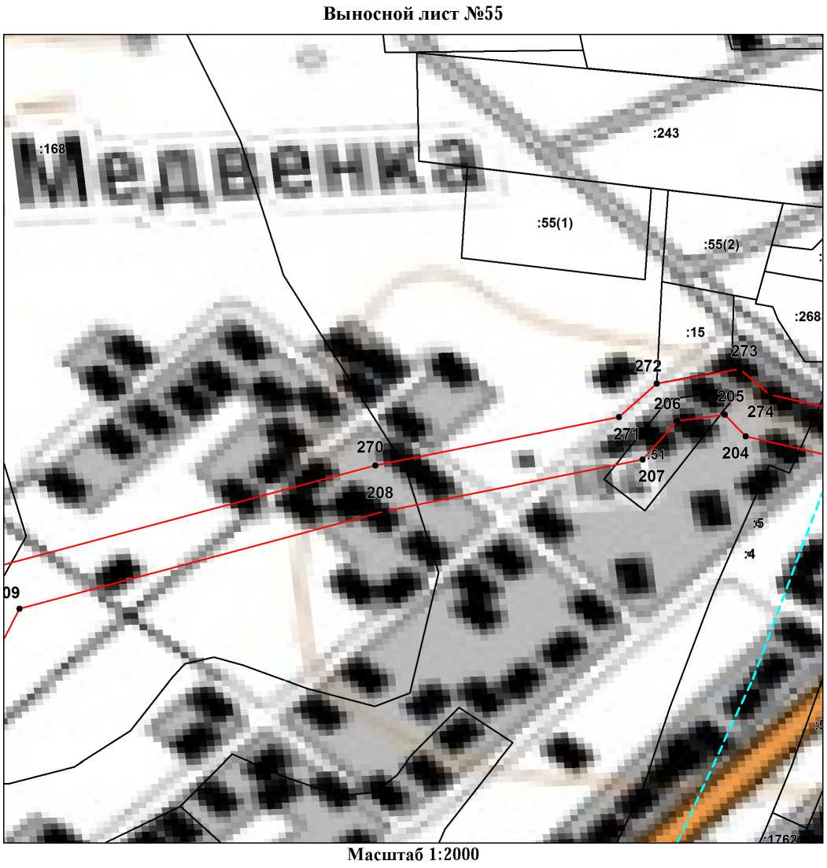
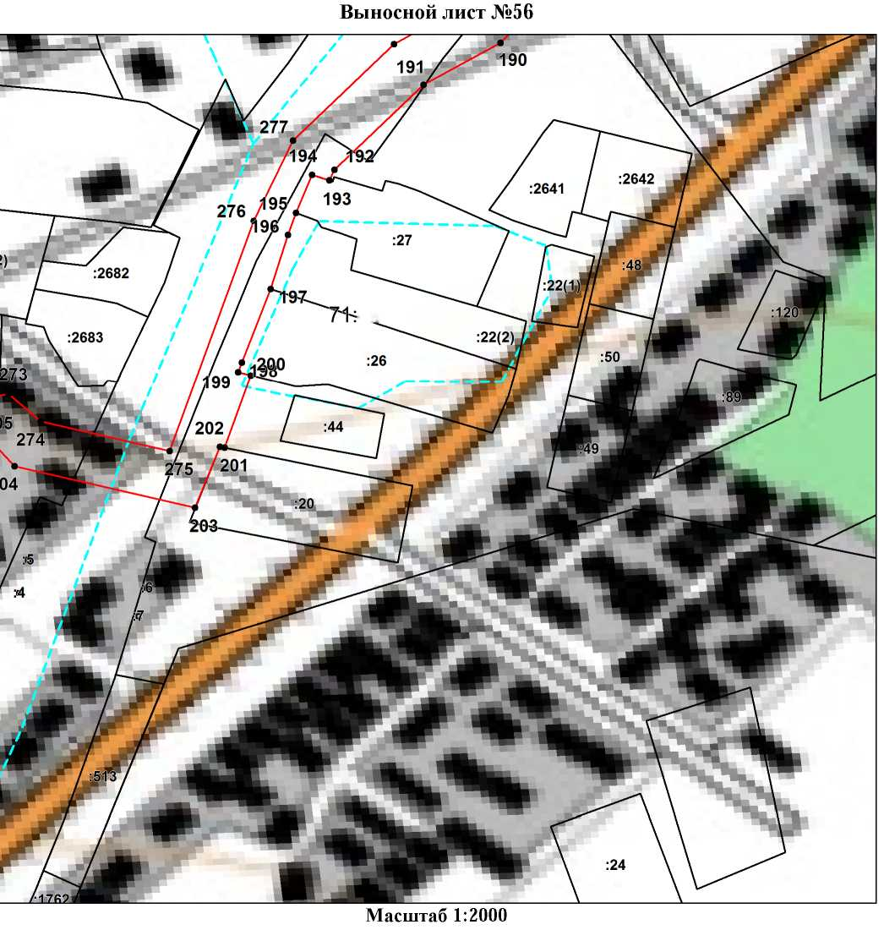
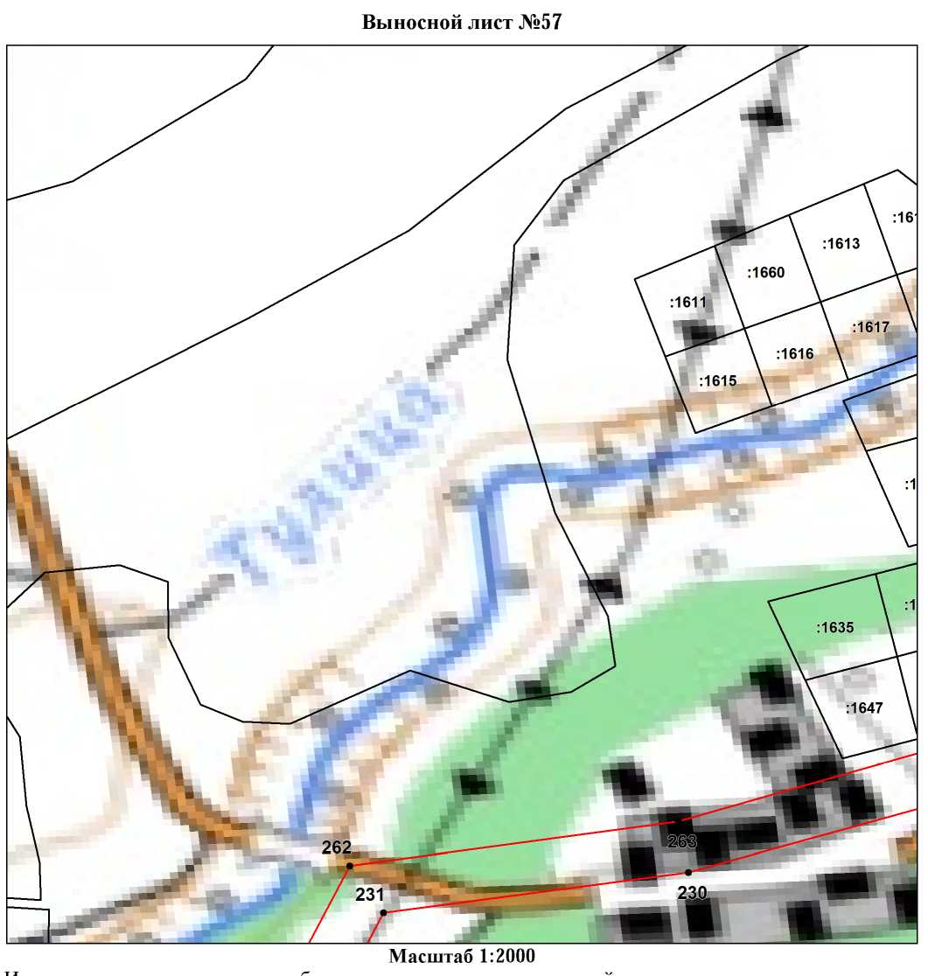
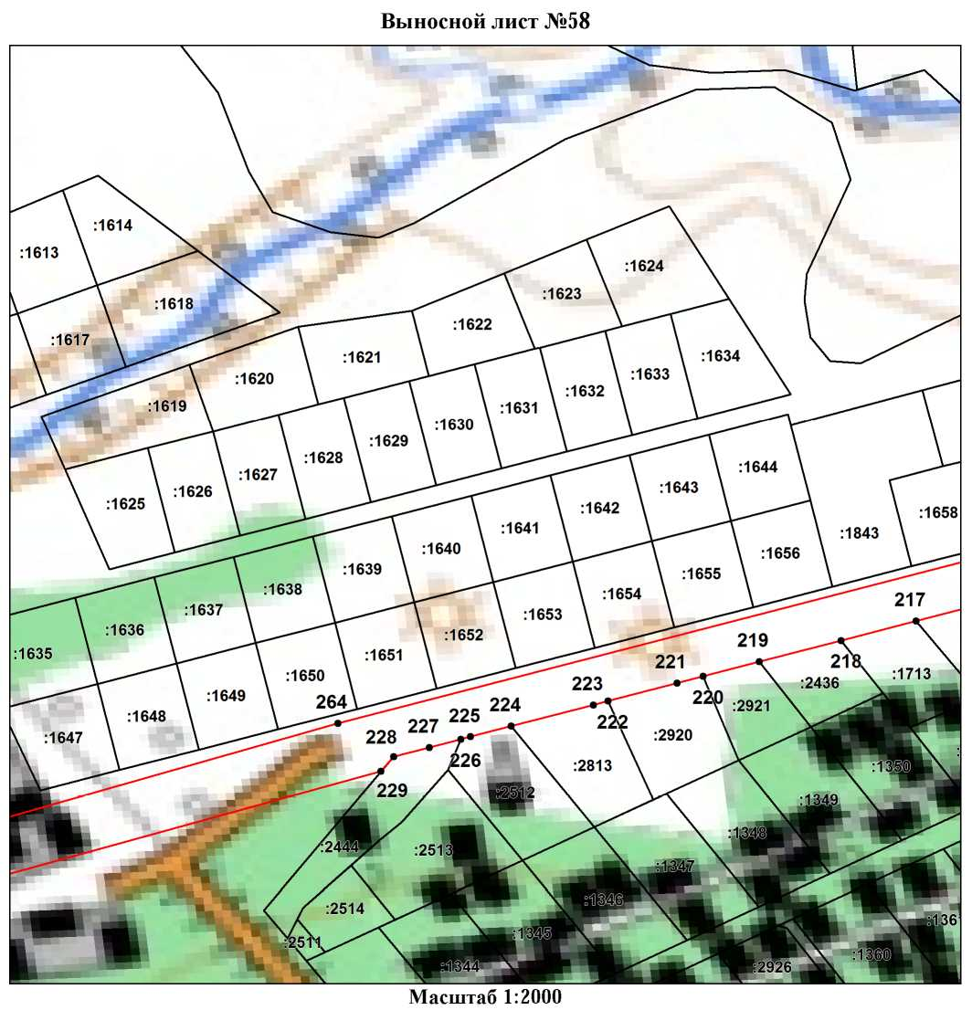
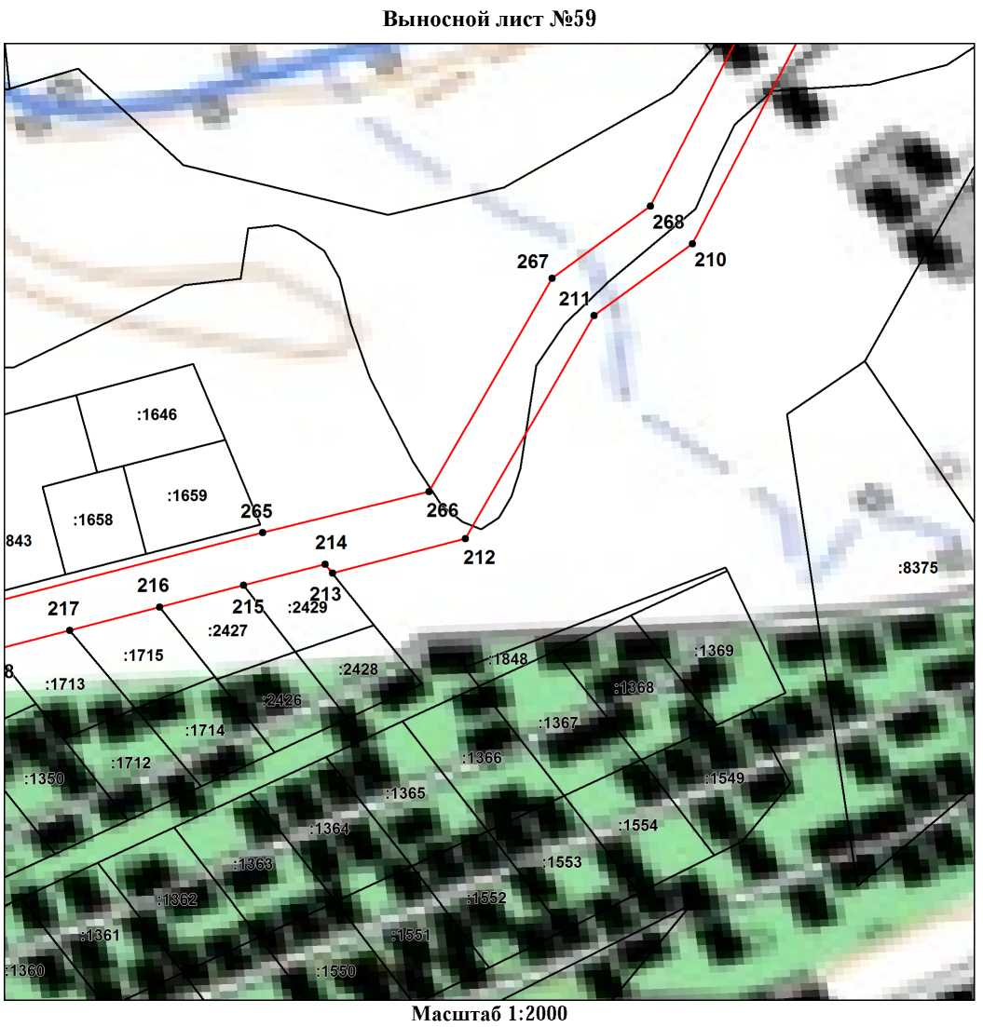
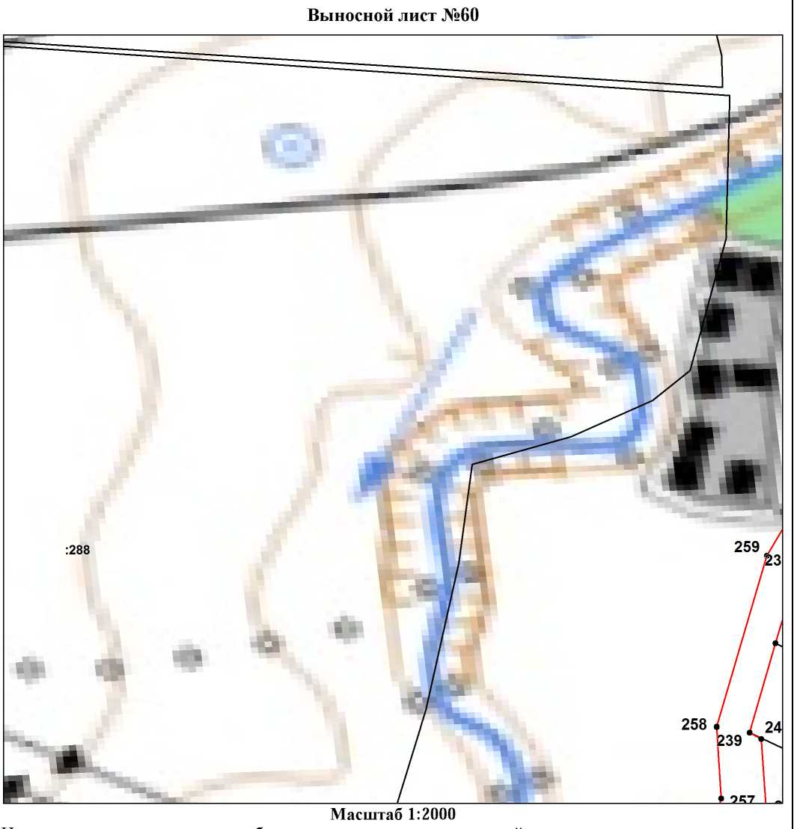
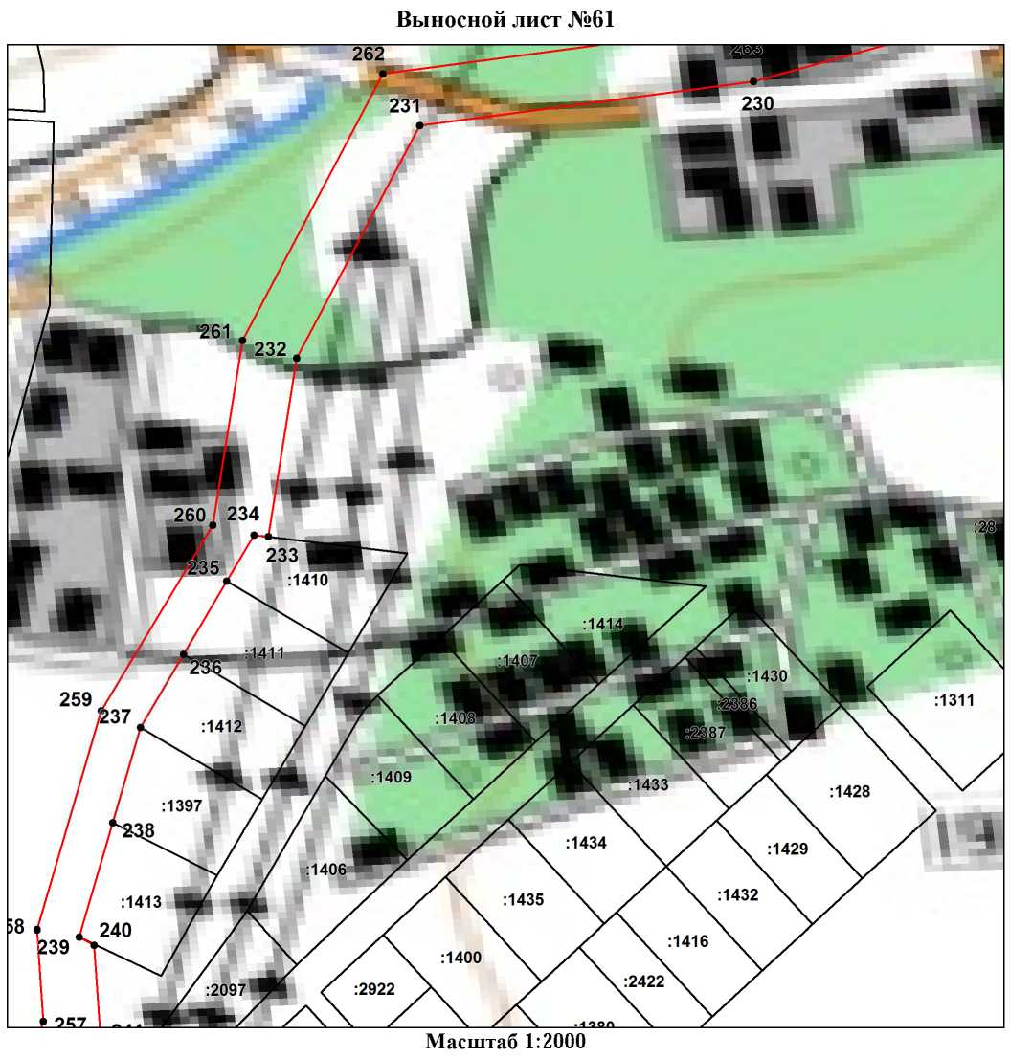
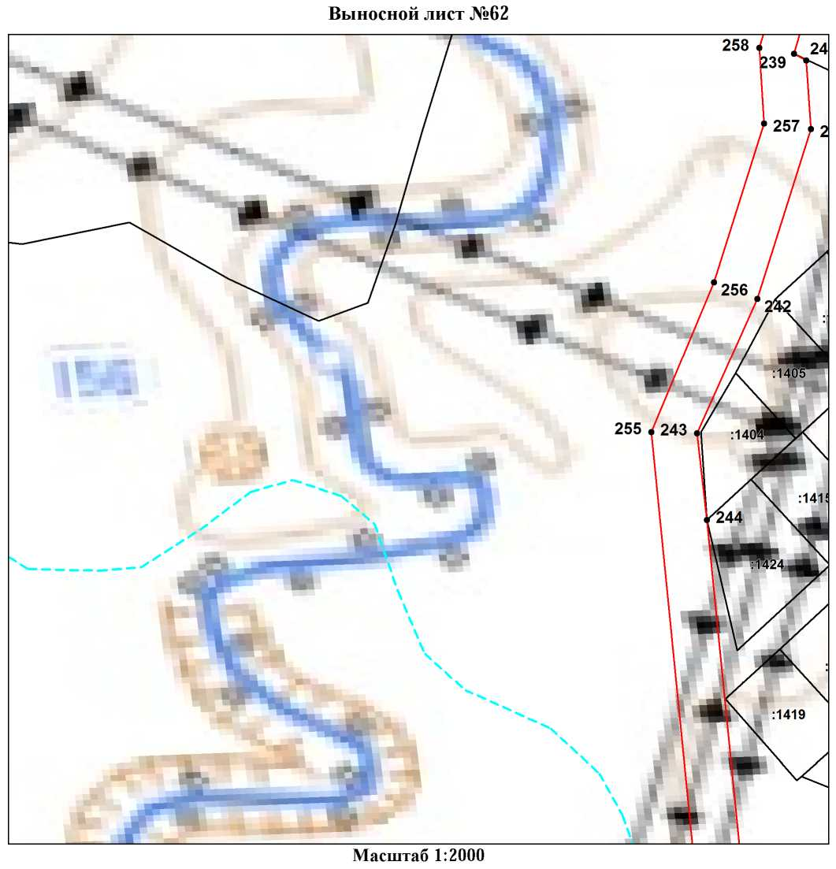
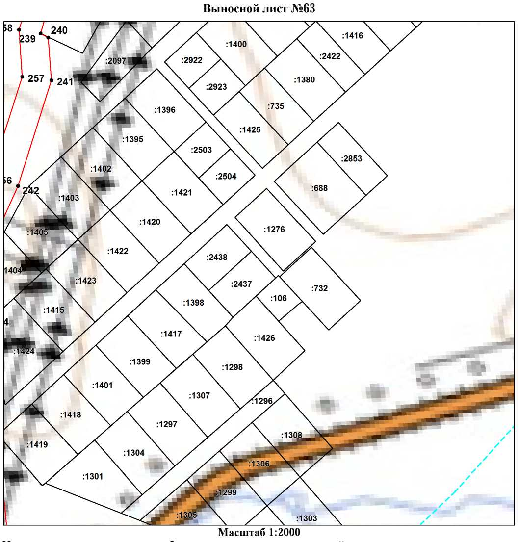
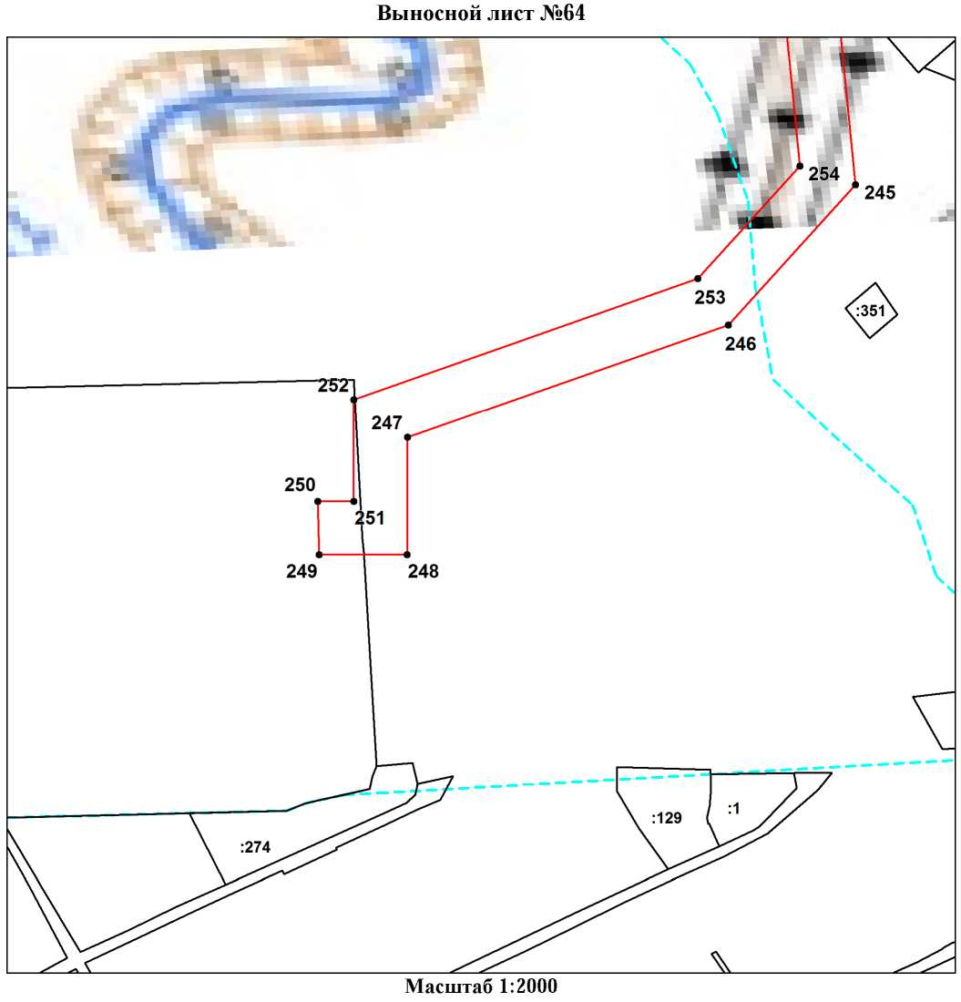

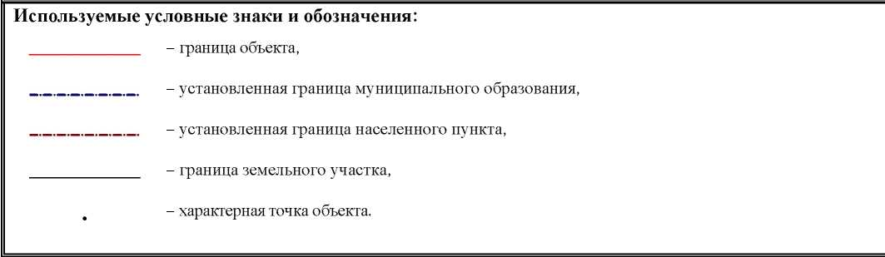

Ведомость координат поворотных точек

@150442
Обозначение характерных точек границ | Координаты
Обозначение характерных точек границ | X | Y
1 | 755217.20 | 272226.84
2 | 755263.35 | 272366.13
3 | 755277.86 | 272417.67
4 | 755289.28 | 272438.40
5 | 755290.19 | 272478.62
6 | 755288.51 | 272499.04
7 | 755358.68 | 272709.13
8 | 755396.84 | 272853.47
9 | 755434.30 | 272972.81
10 | 755515.79 | 273143.63
11 | 755560.27 | 273249.86
12 | 755575.42 | 273343.57
13 | 755626.66 | 273561.03
14 | 755627.75 | 273618.72
15 | 755632.01 | 273936.04
16 | 755591.49 | 273953.87
17 | 755606.53 | 274098.04
18 | 755640.09 | 274298.88
19 | 755680.97 | 274403.39
20 | 755840.55 | 274680.40
21 | 755914.57 | 274807.51
22 | 756123.68 | 275181.36
23 | 756137.30 | 275268.69
24 | 756248.74 | 275461.64
25 | 756593.52 | 276056.26
26 | 756606.28 | 276064.51
27 | 756645.02 | 276067.39
28 | 756943.51 | 276177.01
29 | 757105.59 | 276530.11
30 | 757117.02 | 276592.40
31 | 757095.49 | 276710.79
32 | 757041.83 | 276865.19
33 | 757026.39 | 276864.07
34 | 756865.85 | 276861.94
35 | 756838.16 | 276858.14
36 | 756835.05 | 276874.67
37 | 756799.94 | 276909.88
38 | 756803.72 | 276967.67
39 | 756781.42 | 277059.79
40 | 756738.89 | 277173.34
41 | 756745.96 | 277220.55
42 | 756785.33 | 277248.90
43 | 756787.49 | 277357.21
44 | 756771.85 | 277448.63
45 | 756717.55 | 277662.35
46 | 756717.02 | 277662.19
47 | 756715.87 | 277665.66
48 | 756716.65 | 277665.91
49 | 756709.38 | 277694.54
50 | 756716.23 | 277704.98
51 | 756680.50 | 277881.10
52 | 756670.66 | 277886.64
53 | 756645.35 | 277993.03
54 | 756611.55 | 278175.58
55 | 756590.52 | 278252.80
56 | 756563.26 | 278407.50
57 | 756556.18 | 278489.99
58 | 756508.50 | 278672.68
59 | 756494.31 | 278793.34
60 | 756511.79 | 278798.96
61 | 756505.00 | 278827.33
62 | 756485.39 | 278822.14
63 | 756487.97 | 278812.32
64 | 756472.56 | 278807.18
65 | 756488.78 | 278669.20
66 | 756536.49 | 278486.32
67 | 756543.40 | 278405.06
68 | 756571.03 | 278248.28
69 | 756591.96 | 278171.53
70 | 756625.83 | 277988.65
71 | 756653.34 | 277873.36
72 | 756662.71 | 277868.18
73 | 756695.12 | 277709.25
74 | 756688.04 | 277697.27
75 | 756752.37 | 277444.09
76 | 756767.47 | 277355.65
77 | 756765.63 | 277259.34
78 | 756727.48 | 277231.93
79 | 756718.34 | 277170.84
80 | 756762.28 | 277053.90
81 | 756783.57 | 276965.76
82 | 756779.59 | 276901.98
83 | 756839.80 | 276841.70
84 | 757027.59 | 276845.06
85 | 757076.11 | 276705.59
86 | 757096.66 | 276592.15
87 | 757086.35 | 276536.10
88 | 756928.88 | 276192.80
89 | 756640.91 | 276087.15
90 | 756599.79 | 276083.90
91 | 756578.36 | 276070.01
92 | 756403.31 | 275770.23
93 | 756315.78 | 275618.56
94 | 756118.10 | 275275.39
95 | 756104.55 | 275188.16
96 | 756086.35 | 275157.44
97 | 755963.83 | 274940.14
98 | 755897.16 | 274817.36
99 | 755662.96 | 274412.22
100 | 755620.65 | 274304.06
101 | 755586.76 | 274101.03
102 | 755570.03 | 273941.39
103 | 755611.78 | 273923.32
104 | 755609.59 | 273814.92
105 | 755610.22 | 273764.68
106 | 755610.45 | 273731.32
107 | 755610.58 | 273728.35
108 | 755611.66 | 273703.99
109 | 755612.18 | 273692.52
110 | 755612.45 | 273686.86
111 | 755610.91 | 273685.35
112 | 755608.48 | 273682.09
113 | 755607.82 | 273681.82
114 | 755607.08 | 273602.96
115 | 755606.68 | 273564.83
116 | 755616.17 | 273562.56
117 | 755598.00 | 273481.67
118 | 755583.59 | 273456.60
119 | 755580.05 | 273450.43
120 | 755555.79 | 273347.42
121 | 755541.08 | 273255.75
122 | 755497.57 | 273151.88
123 | 755415.65 | 272980.18
124 | 755408.88 | 272959.72
125 | 755411.50 | 272950.24
126 | 755401.09 | 272934.51
127 | 755377.60 | 272858.95
128 | 755339.55 | 272714.96
129 | 755281.04 | 272525.73
130 | 755270.19 | 272478.03
131 | 755269.89 | 272444.41
132 | 755259.17 | 272424.97
133 | 755244.21 | 272371.91
134 | 755198.07 | 272232.68
135 | 755179.84 | 272165.38
136 | 755146.10 | 272081.68
137 | 755138.79 | 272069.75
138 | 755026.94 | 271763.22
139 | 754992.97 | 271660.98
140 | 754947.54 | 271532.34
141 | 754902.92 | 271419.44
142 | 754868.90 | 271418.76
143 | 754634.48 | 271389.14
144 | 754639.91 | 271498.26
145 | 754567.06 | 271499.89
146 | 754488.50 | 271459.86
147 | 754460.25 | 271397.13
148 | 754412.43 | 271392.14
149 | 754387.12 | 271244.78
150 | 754389.36 | 271147.20
151 | 754108.32 | 271026.87
152 | 754048.16 | 271040.10
153 | 754035.76 | 271043.89
154 | 754010.56 | 271014.91
155 | 754006.25 | 271008.14
156 | 753998.80 | 271012.04
157 | 753965.97 | 271004.16
158 | 753958.28 | 270919.09
159 | 753960.38 | 270877.22
160 | 753959.86 | 270789.93
161 | 753972.58 | 270677.57
162 | 753980.49 | 270472.05
163 | 754040.81 | 270412.02
164 | 753926.55 | 270291.96
165 | 753792.40 | 270417.58
166 | 753717.30 | 270420.92
167 | 753587.53 | 270238.05
168 | 753581.40 | 270229.94
169 | 753563.46 | 270205.99
170 | 753553.88 | 270193.51
171 | 753537.96 | 270172.44
172 | 753522.00 | 270151.31
173 | 753506.05 | 270130.20
174 | 753490.10 | 270109.09
175 | 753406.35 | 269994.91
176 | 753408.13 | 269993.39
177 | 753384.22 | 269952.54
178 | 753379.75 | 269955.35
179 | 753325.87 | 269854.27
180 | 753380.30 | 269830.06
181 | 753447.56 | 269788.55
182 | 753464.20 | 269767.64
183 | 753414.49 | 269649.04
184 | 753326.34 | 269394.28
185 | 753209.83 | 269206.42
186 | 753168.42 | 269095.93
187 | 753105.67 | 268970.22
188 | 753072.21 | 268933.38
189 | 753063.51 | 268904.15
190 | 752965.23 | 268808.24
191 | 752948.58 | 268777.54
192 | 752914.46 | 268741.74
193 | 752910.32 | 268739.71
194 | 752912.54 | 268732.73
195 | 752897.27 | 268726.39
196 | 752888.51 | 268723.14
197 | 752866.75 | 268716.27
198 | 752837.37 | 268704.64
199 | 752833.48 | 268703.07
200 | 752832.13 | 268708.25
201 | 752803.16 | 268697.71
202 | 752803.49 | 268695.86
203 | 752778.99 | 268685.88
204 | 752795.73 | 268613.57
205 | 752805.04 | 268604.72
206 | 752802.19 | 268584.12
207 | 752785.64 | 268569.28
208 | 752763.51 | 268458.47
209 | 752721.52 | 268301.30
210 | 752588.49 | 268232.44
211 | 752562.44 | 268196.60
212 | 752481.09 | 268149.96
213 | 752468.64 | 268101.71
214 | 752471.85 | 268098.94
215 | 752464.14 | 268069.27
216 | 752456.23 | 268038.82
217 | 752447.76 | 268006.22
218 | 752440.55 | 267978.48
219 | 752432.65 | 267948.07
220 | 752427.26 | 267927.34
221 | 752424.74 | 267917.62
222 | 752418.09 | 267892.03
223 | 752416.71 | 267886.71
224 | 752408.81 | 267856.28
225 | 752404.87 | 267841.12
226 | 752403.93 | 267837.51
227 | 752400.93 | 267825.95
228 | 752397.49 | 267812.72
229 | 752392.06 | 267807.95
230 | 752340.90 | 267622.33
231 | 752325.31 | 267504.28
232 | 752243.01 | 267460.79
233 | 752179.70 | 267450.70
234 | 752180.24 | 267445.65
235 | 752163.86 | 267435.98
236 | 752138.02 | 267420.74
237 | 752112.18 | 267405.49
238 | 752078.34 | 267395.67
239 | 752038.12 | 267383.87
240 | 752035.30 | 267389.14
241 | 752005.88 | 267391.25
242 | 751932.95 | 267368.23
243 | 751874.91 | 267342.30
244 | 751837.73 | 267346.50
245 | 751684.30 | 267361.79
246 | 751632.15 | 267314.57
247 | 751590.22 | 267195.34
248 | 751546.55 | 267195.17
249 | 751546.59 | 267162.46
250 | 751566.40 | 267161.96
251 | 751566.43 | 267175.34
252 | 751604.36 | 267175.36
253 | 751649.33 | 267303.18
254 | 751691.20 | 267341.03
255 | 751875.42 | 267322.68
256 | 751939.93 | 267349.48
257 | 752008.28 | 267371.10
258 | 752040.67 | 267368.98
259 | 752118.10 | 267391.62
260 | 752183.73 | 267431.08
261 | 752249.32 | 267441.54
262 | 752343.51 | 267491.24
263 | 752360.55 | 267618.42
264 | 752409.90 | 267792.02
265 | 752483.26 | 268076.19
266 | 752498.18 | 268136.74
267 | 752575.96 | 268181.37
268 | 752602.11 | 268217.16
269 | 752738.65 | 268287.72
270 | 752783.06 | 268454.24
271 | 752804.00 | 268559.09
272 | 752818.37 | 268575.44
273 | 752824.56 | 268611.17
274 | 752813.64 | 268624.00
275 | 752801.73 | 268675.77
276 | 752894.06 | 268709.49
277 | 752926.14 | 268725.21
278 | 752964.78 | 268765.64
279 | 752981.36 | 268796.04
280 | 753081.10 | 268893.37
281 | 753090.16 | 268923.56
282 | 753122.38 | 268959.08
283 | 753186.71 | 269087.78
284 | 753227.65 | 269197.22
285 | 753269.17 | 269263.08
286 | 753344.62 | 269386.02
287 | 753433.22 | 269642.00
288 | 753487.04 | 269770.26
289 | 753461.03 | 269803.76
290 | 753389.33 | 269847.94
291 | 753353.08 | 269864.08
292 | 753423.15 | 269994.36
293 | 753515.51 | 270115.04
294 | 753512.31 | 270117.46
295 | 753527.82 | 270133.96
296 | 753529.25 | 270133.00
297 | 753585.76 | 270206.83
298 | 753582.72 | 270209.86
299 | 753695.49 | 270367.38
300 | 753690.65 | 270370.50
301 | 753707.79 | 270394.13
302 | 753712.35 | 270391.73
303 | 753719.22 | 270400.50
304 | 753784.28 | 270397.82
305 | 753926.89 | 270264.20
306 | 754068.71 | 270412.17
307 | 754000.06 | 270480.37
308 | 753992.55 | 270678.95
309 | 753979.83 | 270791.20
310 | 753980.37 | 270877.94
311 | 753978.31 | 270918.93
312 | 753984.51 | 270988.21
313 | 754021.65 | 270996.98
314 | 754034.73 | 271014.20
315 | 754048.23 | 271027.64
316 | 754113.86 | 271011.97
317 | 754409.68 | 271133.82
318 | 754407.14 | 271244.27
319 | 754429.46 | 271373.82
320 | 754473.78 | 271378.44
321 | 754503.93 | 271445.35
322 | 754524.35 | 271455.72
323 | 754538.05 | 271472.87
324 | 754567.25 | 271484.97
325 | 754570.29 | 271486.23
326 | 754595.89 | 271486.22
327 | 754623.86 | 271486.21
328 | 754622.52 | 271445.42
329 | 754620.26 | 271377.03
330 | 754614.48 | 271376.66
331 | 754613.99 | 271366.34
332 | 754870.18 | 271398.79
333 | 754916.75 | 271399.74
334 | 754966.25 | 271525.28
335 | 755011.87 | 271654.46
336 | 755045.84 | 271756.66
337 | 755098.34 | 271899.06
338 | 755156.70 | 272060.74
339 | 755163.86 | 272072.41
340 | 755198.76 | 272158.83
1 | 755217.20 | 272226.84

