Приложение

Описание местоположения границ публичного сервитута

Основной лист

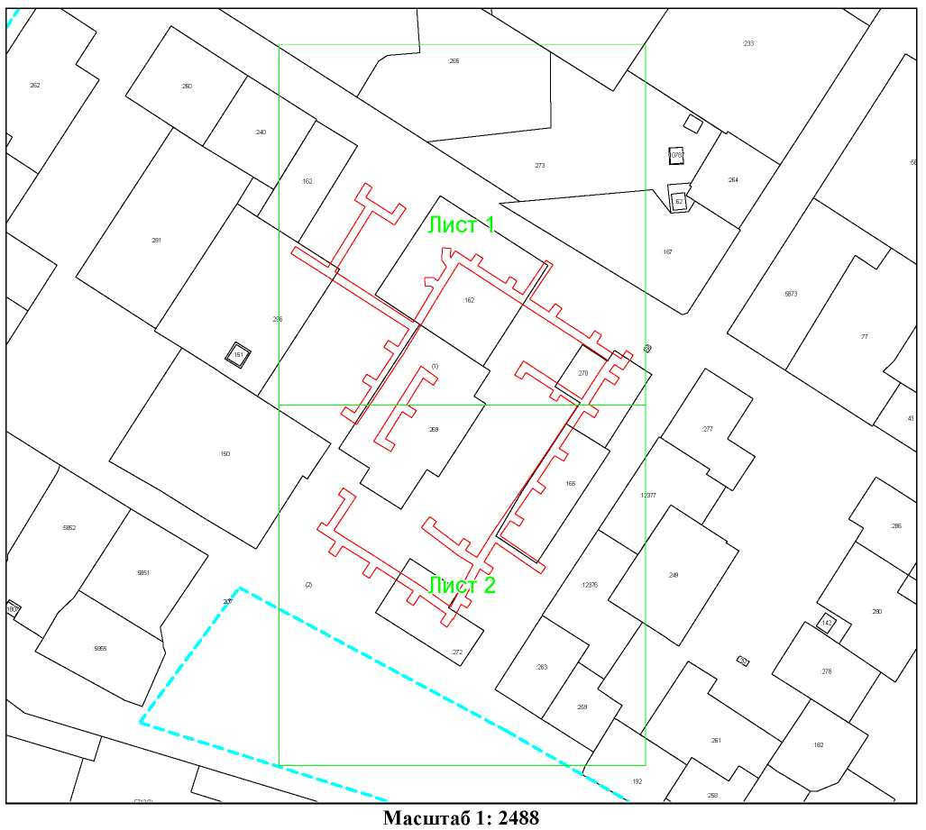
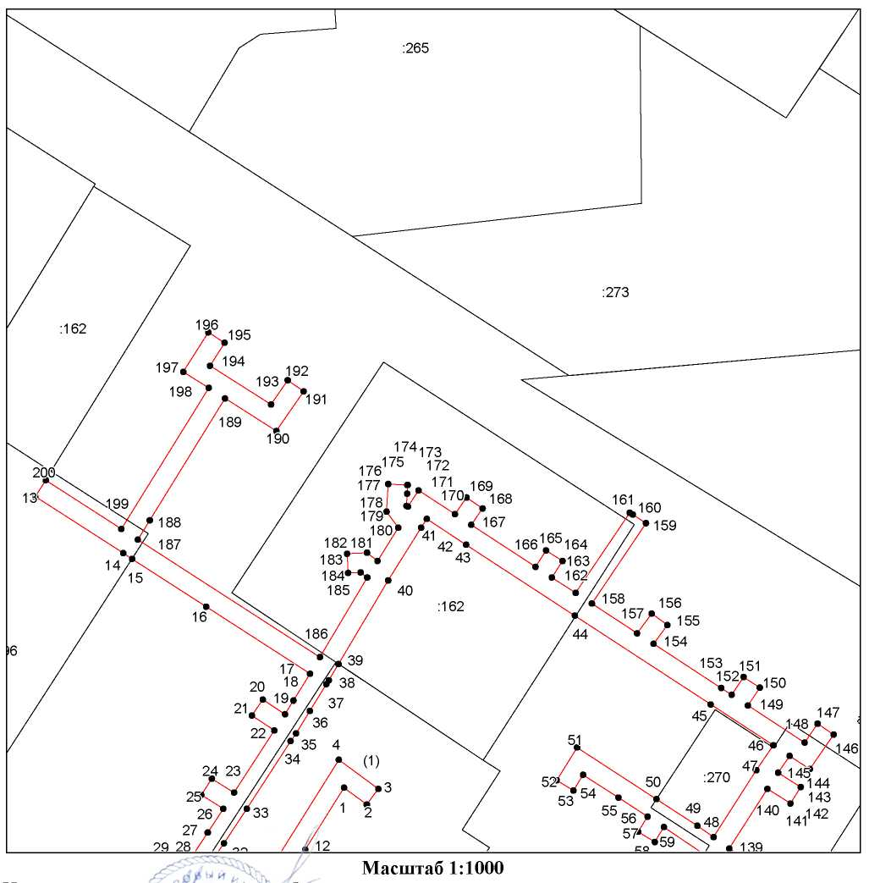
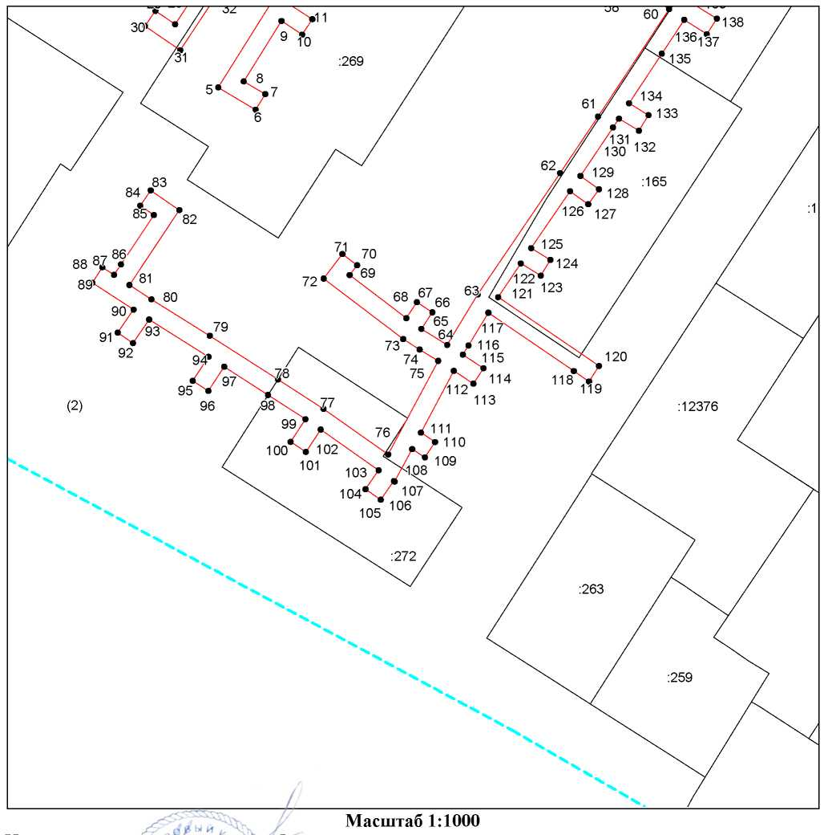
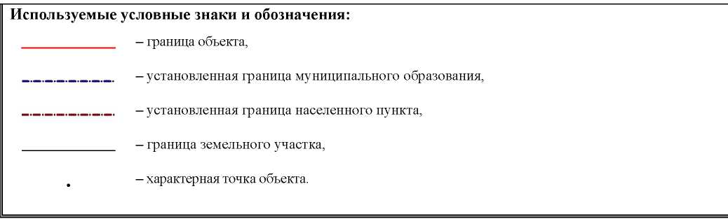

Ведомость координат поворотных точек

@150634, @150635
Обозначение характерных точек границ | Координаты
Обозначение характерных точек границ | X | Y
ПС1(1): @150634
1 | 740847.03 | 259548.96
2 | 740843.55 | 259553.65
3 | 740846.77 | 259556.03
4 | 740852.81 | 259547.88
5 | 740816.44 | 259525.16
6 | 740811.61 | 259533.30
7 | 740815.03 | 259535.37
8 | 740817.75 | 259530.69
9 | 740830.88 | 259538.88
10 | 740827.94 | 259543.38
11 | 740831.28 | 259545.57
12 | 740834.27 | 259541.00
1 | 740847.03 | 259548.96
ПС1(2): @150635
13 | 740907.15 | 259485.39
14 | 740895.44 | 259503.50
15 | 740894.28 | 259505.30
16 | 740884.41 | 259520.56
17 | 740870.58 | 259541.96
18 | 740865.02 | 259538.55
19 | 740862.18 | 259536.82
20 | 740865.24 | 259532.23
21 | 740861.92 | 259530.01
22 | 740858.84 | 259534.61
23 | 740846.02 | 259526.31
24 | 740848.92 | 259521.73
25 | 740845.54 | 259519.59
26 | 740842.67 | 259524.12
27 | 740837.75 | 259520.87
28 | 740830.15 | 259515.86
29 | 740833.09 | 259511.57
30 | 740829.79 | 259509.31
31 | 740824.55 | 259516.95
32 | 740835.58 | 259524.23
33 | 740842.68 | 259528.91
34 | 740856.64 | 259537.95
35 | 740858.25 | 259539.11
36 | 740862.87 | 259541.93
37 | 740868.41 | 259545.32
38 | 740869.20 | 259545.80
39 | 740872.58 | 259547.80
40 | 740889.85 | 259558.05
41 | 740900.70 | 259564.84
42 | 740902.53 | 259565.99
43 | 740897.21 | 259574.11
44 | 740882.57 | 259596.48
45 | 740864.24 | 259624.47
46 | 740855.78 | 259637.39
47 | 740850.65 | 259633.87
48 | 740836.82 | 259625.04
49 | 740839.15 | 259621.73
50 | 740844.66 | 259613.28
51 | 740855.35 | 259596.96
52 | 740848.54 | 259592.77
53 | 740846.45 | 259596.18
54 | 740849.72 | 259598.19
55 | 740844.99 | 259605.45
56 | 740841.08 | 259611.45
57 | 740837.92 | 259609.53
58 | 740835.84 | 259612.95
59 | 740838.89 | 259614.80
60 | 740833.46 | 259622.86
61 | 740810.15 | 259607.47
62 | 740797.87 | 259599.25
63 | 740771.50 | 259581.39
64 | 740760.59 | 259574.79
65 | 740764.05 | 259569.19
66 | 740767.63 | 259571.55
67 | 740769.83 | 259568.21
68 | 740766.36 | 259565.92
69 | 740775.72 | 259553.63
70 | 740777.86 | 259555.27
71 | 740780.30 | 259552.10
72 | 740774.97 | 259548.02
73 | 740761.84 | 259565.26
74 | 740759.54 | 259568.82
75 | 740757.11 | 259572.81
76 | 740736.79 | 259562.01
77 | 740746.68 | 259547.97
78 | 740753.08 | 259538.11
79 | 740762.57 | 259523.35
80 | 740770.45 | 259510.74
81 | 740773.59 | 259505.96
82 | 740789.84 | 259516.75
83 | 740794.09 | 259510.55
84 | 740790.79 | 259508.29
85 | 740788.77 | 259511.24
86 | 740778.08 | 259504.14
87 | 740775.77 | 259502.61
88 | 740777.41 | 259500.06
89 | 740774.04 | 259497.90
90 | 740768.22 | 259506.85
91 | 740763.24 | 259503.41
92 | 740760.97 | 259506.70
93 | 740766.06 | 259510.22
94 | 740758.00 | 259523.11
95 | 740752.78 | 259519.68
96 | 740750.58 | 259523.06
97 | 740755.85 | 259526.49
98 | 740749.70 | 259535.96
99 | 740744.44 | 259544.07
100 | 740739.55 | 259540.85
101 | 740737.35 | 259544.19
102 | 740742.20 | 259547.39
103 | 740733.36 | 259559.93
104 | 740729.24 | 259557.07
105 | 740726.96 | 259560.36
106 | 740731.05 | 259563.20
107 | 740730.91 | 259563.40
108 | 740737.99 | 259567.20
109 | 740736.16 | 259569.94
110 | 740739.49 | 259572.16
111 | 740741.54 | 259569.09
112 | 740754.96 | 259576.20
113 | 740752.16 | 259580.46
114 | 740755.50 | 259582.66
115 | 740758.45 | 259578.17
116 | 740760.46 | 259579.39
117 | 740767.58 | 259583.69
118 | 740754.89 | 259602.21
119 | 740752.63 | 259605.51
120 | 740756.01 | 259607.66
121 | 740770.96 | 259585.84
122 | 740778.25 | 259590.72
123 | 740775.60 | 259595.06
124 | 740779.02 | 259597.14
125 | 740781.56 | 259592.96
126 | 740793.93 | 259601.41
127 | 740791.10 | 259605.34
128 | 740794.35 | 259607.68
129 | 740797.25 | 259603.65
130 | 740807.78 | 259610.70
131 | 740809.68 | 259611.97
132 | 740807.04 | 259616.31
133 | 740810.45 | 259618.39
134 | 740813.02 | 259614.18
135 | 740823.75 | 259621.25
136 | 740831.12 | 259626.11
137 | 740827.99 | 259631.04
138 | 740831.37 | 259633.18
139 | 740834.47 | 259628.29
140 | 740846.79 | 259636.15
141 | 740843.78 | 259640.87
142 | 740847.15 | 259643.02
143 | 740850.13 | 259638.36
144 | 740853.59 | 259640.73
145 | 740850.89 | 259644.87
146 | 740857.98 | 259649.76
147 | 740860.25 | 259646.47
148 | 740856.37 | 259643.79
149 | 740864.01 | 259632.13
150 | 740867.69 | 259634.57
151 | 740869.91 | 259631.24
152 | 740866.20 | 259628.78
153 | 740867.61 | 259626.63
154 | 740876.74 | 259612.68
155 | 740880.59 | 259615.52
156 | 740882.96 | 259612.30
157 | 740878.93 | 259609.33
158 | 740885.04 | 259600.01
159 | 740901.63 | 259611.15
160 | 740903.41 | 259608.44
161 | 740903.79 | 259607.78
162 | 740887.23 | 259596.66
163 | 740890.43 | 259591.76
164 | 740893.87 | 259593.95
165 | 740896.02 | 259590.58
166 | 740892.62 | 259588.42
167 | 740901.30 | 259575.17
168 | 740904.69 | 259577.47
169 | 740906.93 | 259574.16
170 | 740903.49 | 259571.82
171 | 740908.41 | 259564.31
172 | 740905.06 | 259562.12
173 | 740905.21 | 259561.80
174 | 740907.73 | 259561.95
175 | 740909.50 | 259562.06
176 | 740909.50 | 259561.99
177 | 740909.74 | 259558.07
178 | 740904.02 | 259557.72
179 | 740900.70 | 259560.13
180 | 740893.86 | 259555.84
181 | 740895.56 | 259553.70
182 | 740895.33 | 259549.58
183 | 740891.34 | 259549.81
184 | 740891.48 | 259552.40
185 | 740890.42 | 259553.74
186 | 740874.02 | 259544.01
187 | 740898.27 | 259506.49
188 | 740902.23 | 259508.93
189 | 740927.42 | 259524.46
190 | 740920.68 | 259535.04
191 | 740928.87 | 259540.66
192 | 740931.13 | 259537.36
193 | 740926.13 | 259533.93
194 | 740934.13 | 259521.36
195 | 740938.91 | 259524.38
196 | 740941.04 | 259521.00
197 | 740932.89 | 259515.85
198 | 740929.56 | 259521.08
199 | 740900.44 | 259503.13
200 | 740910.54 | 259487.52
13 | 740907.15 | 259485.39

